Respondent Name: ________________

TARRANT COUNTY HOSPITAL DISTRICT d/b/a
JPS HEALTH NETWORK

RFP NO. 18-1023

REQUEST FOR PROPOSALS
FOR CONSTRUCTION SERVICES FOR
JPOC 1350 OPAT CLINIC

Response Deadline:
October 14th, 2022
2:30 PM CST

TABLE OF CONTENTS

I. PROJECT DESCRIPTION, GENERAL REQUIREMENTS AND PRE-PROPOSAL CONFERENCE 1 – 4
II. OPENING DATE, TIME, PROCEDURES, CONTACTS 4 – 8
III. TERMS AND CONDITIONS 8 – 12
IV. EXAMINATION OF DOCUMENTS AND SITE VISIT 12 – 13
V. EVALUATION CRITERIA 13 – 16
VI. PROPOSAL SUBMITTAL REQUIREMENTS 16 – 19
EXHIBIT “A” – RFP PROPOSAL CHECKLIST 20 – 21
EXHIBIT “B” –CONTRACT FORM (A102 – 2017) 22
EXHIBIT “C” – GENERAL CONDITIONS (A201-2017 with revisions) 23
EXHIBIT “D” – BID FORM 24 – 30
EXHIBIT “E” –VENDOR VERIFICATION FORM 31
EXHIBIT “F” – GOOD FAITH EVALUATION FORM (Supplier Diversity) 32 –33
EXHIBIT “G” – CONFLICT OF INTEREST QUESTIONAIRE FORM 34 – 36
EXHIBIT “H” – RESPONDENT’S PROPOSED AMENDMENT FORM 37 - 38
EXHIBIT “I” – PROPOSAL SIGNATURE FORM 39
EXHIBIT “J” – SAMPLE FORMS
- J.1 A310 – BID BOND
- J.2 A312 – PAYMENT & PERFORMANCE BOND
- J.3 G702 – APPLICATION AND CERTIFICATION FOR PAYMENT
- J.4 G703 – CONTINUATION SHEET
- J.5 G704 – CERTIFICATE OF SUBSTANTIAL COMPLETION
- J.6 G705 – LIST OF SUBCONTRACTORS
- J.7 G706 – CONTRACTORS AFFIDAVIT OF PAYMENT
- J.8 G706A – CONTRACTORS AFFIDAVIT OF RELEASE OF LIENS
- J.9 G707 – CONSENT OF SURETY TO FINAL PAYMENT
- J.10 G707A – CONSENT OF SURETY TO REDUCTION IN RETAINAGE

EXHIBIT “K” – DESCRIPTION OF CONTRACT FORMS 40

*NOTES: (1) EXHIBITS “A”, “D”, “E”, “F”, “G”, “H” AND “I” MUST BE COMPLETED AND RETURNED WITH THE PROPOSAL, and (2) This Table of Contents is intended as an aid to Respondents and not as a comprehensive listing of the bid package. Respondents are responsible for reading the entire bid package and complying with all requirements in the RFP documents.

I. PROJECT DESCRIPTION, GENERAL REQUIREMENTS AND PRE-PROPOSAL CONFERENCE
1.1 Pursuant to the provisions in Section 2269 of the Texas Local Government Code (“Chapter 2269”) and related laws, the Tarrant County Hospital District (the “District”) is seeking Proposals ("Proposals") from construction firms (“Respondents”) qualified and experienced in providing construction services for JPOC 1350 OPAT CLINIC (the “Project”). The applicable surveys, models, sketches, drawings, specifications, digital models, and other similar materials for construction of the Project (“Construction Documents”) have been prepared by e4H Architecture. (“Architect”). The Construction Documents may be obtained at no charge at District’s online “JPS Procurement System” located on the District’s Website at: https://jpshealth.gob2g.com/ (the “District’s RFP Portal”). Respondents are responsible for obtaining and examining the Construction Documents prior to submission of a Proposal.
1.2 Any contract resulting from this RFP will be in the form of contract attached to this RFP as Exhibit “B” (the “Contract Form”). Respondents must provide written confirmation of their acceptance of the Contract Form, inclusive of its respective exhibits and attachments. Please provide written confirmation in a separate document placed after the Cover Sheet. TO ENSURE THAT THIS RFP IS BASED ON FAIR COMPETITION, THE CONTRACT TERMS AND CONDITIONS DESCRIBED IN THIS RFP AND EXHIBITS “A” AND “B”: ARE NON-NEGOTIABLE. Proposed changes and amendments may be submitted, subject to the limitations and provisions of Section 2.12. Any and all proposed amendments shall be presented within EXHIBIT “H” Respondents Proposed Amendment Form. After the award has been made, the District reserves the right to conduct finalization of details in the Contract with the selected Respondent after receipt of the final Proposals.
1.3 The District maintains a policy of encouraging and engaging in business transactions with vendors who qualify and are certified under applicable law as Historically Underutilized Businesses (“HUBs”), Small Minority and Women Owned Business Enterprises (“SMWBEs”), and Individuals with Disabilities and Service-Disabled Veterans Owned Business Enterprises (“DOBEs”). HUBs, SMWBEs, and DOBEs are referred to herein as Disadvantaged Business Enterprises (“DBEs”). The District also encourages its vendors to utilize subcontractors and vendors who qualify and are certified under applicable law as DBEs. Prior to the District’s consideration of a Respondent’s Proposal each Respondent is required to and shall register as a Vendor in the District’s RFP Portal. Prior to the Contract Award a Respondent’s good faith efforts to utilize DBE subcontractors and vendors in its business transactions shall be part of the criteria under which the Vendor Proposals will be considered. Each Respondent will be required to show in its Vendor Proposal its historical efforts to utilize DBE subcontractors and vendors in its business transactions.
1.4 COMPLIANCE WITH TEXAS GOVERNMENT CODE SECTION 2252.908. Texas Government Code Section 2252.908 (“Section 2252.908”) states that a governmental entity or state agency may not enter into certain contracts with a business entity unless the business entity submits Form 1295, a disclosure of interested parties, to the governmental entity or state agency at the time the business entity submits the signed contract to the governmental entity or state agency. Section 2252.908 applies to all contracts entered into from and after January 1, 2016 between business entities and Texas governmental entities and state agencies which meet either one of the following criteria:
a. the contract requires a vote of the governing body of the Texas governmental entity, or
b. the contract has a contractual value of at least $1 Million.
The Texas Ethics Commission has adopted a Certificate of Interested Parties form (“Form 1295”) and has made it available on the TEC website.
In 2017 Section 2252.908 was amended to provide that the requirements of Section 2252.908 do not apply to the following contracts entered into or amended after January 1, 2018:
A a contract with a publicly traded business entity, including a wholly owned subsidiary of the business entity;
B. a contract with an electric utility, as that term is defined by Section 31.002, Texas Utilities Code; or
C. a contract with a gas utility, as that term is defined by Section 121.001, Texas Utilities Code.
1.5 In the event a Contract Award is issued pursuant to this RFP, the Respondent receiving the Contract Award shall be required to comply with the provisions of Section 2252.908, Texas Government Code, and the Chapter 46 Rules of the TEC, prior to entry into a contract with the District for the sale of the Products to the District. The TEC has posted a video tutorial to its website for business entity filings of Form 1295. The TEC video provides step-by-step tutorials for creating login accounts for the business entity for completing and filing Form 1295. The TEC video tutorials can be viewed on its website at:
https://www.ethics.state.tx.us/whatsnew/elf_info_form1295.htm
The TEC’s FAQs are posted on its website at:
https://www.ethics.state.tx.us/whatsnew/FAQ_Form1295.html
1.6 COMPLIANCE WITH TEXAS GOVERNMENT CODE SECTION 2270.001 et seq. In 2017 Texas Government Code Section 2270.001 et seq. was enacted to provide that a Texas governmental entity is prohibited from entering into a contract with a company unless the contract contains a written verification by the company that (i) the company does not boycott Israel, and (ii) the company will not boycott Israel during the term of the contract. For the purposes of this RFP and any Contract Award pursuant to this RFP, and in compliance with the Texas Government Code, “boycott Israel” means refusing to deal with, terminating business activities with, or otherwise taking any action that is intended to penalize, inflict harm on, or limit commercial relationships specifically with Israel, or with a person or entity doing business in Israel or in an Israel-controlled territory, but does not include an action made for ordinary business purposes. Respondents are hereby notified that respect to any Contract Award the vendor shall comply with the Texas Government Code Section 2270.001 et seq. verification requirements, the failure or refusal of which shall result in the withdrawal of the Contract Award. Respondent’s signature affixed to the Vendor Certification Form attached to this RFP as Exhibit “E” shall be deemed to be the Respondent’s certification to the District that the Respondent shall comply with these terms set forth.
1.7 COMPLIANCE WITH TEXAS GOVERNMENT CODE SECTIONS 2252.151 et seq. In 2017 Texas Government Code Chapter 2252 was amended by adding Sections 2252.151 et seq. to provide that a Texas governmental entity is prohibited from entering into a contract with a company that engages in certain scrutinized business operations in Sudan, Iran, or with foreign terrorist organizations. For the purposes of this RFP and any Contract Award: (i) “scrutinized business operations in Sudan” shall have the meaning ascribed to that term as set forth in Section 2270.0001 et seq. of the Texas Government Code; (ii) “scrutinized business operations in Iran” shall have the meaning ascribed to that term as set forth in Section 2270.0101 et seq. of the Texas Government Code; and (iii) “scrutinized business operations with designated foreign terrorist organizations” shall have the meaning ascribed to that term as set forth in Section 2270.0151 et seq. of the Texas Government Code. Respondent’s signature affixed to the Vendor Certification Form attached to this RFP as Exhibit “E” shall be deemed to be the Respondent’s certification to the District that the Respondent does not engage in scrutinized business operations in Sudan, Iran or with foreign terrorist organizations.
1.8 EACH RESPONDENT ACKNOWLEDGES THAT THE DISTRICT IS A GOVERNMENTAL BODY OPERATING UNDER AND SUBJECT TO THE PROVISIONS OF THE TEXAS PUBLIC INFORMATION ACT (“TPIA”) (CHAPTER 552 OF THE TEXAS GOVERNMENT CODE) AND THEREBY ACKNOWLEDGES THAT INFORMATION THAT IS COLLECTED, ASSEMBLED, OR MAINTAINED IN CONNECTION WITH THE TRANSACTION OF OFFICIAL BUSINESS BY A GOVERNMENTAL BODY IS CONSIDERED PUBLIC INFORMATION POTENTIALLY SUBJECT TO DISCLOSURE PURSUANT TO A VALID TPIA REQUEST AND HEREBY ASSUMES FULL RESPONSIBILITY AND ALL COSTS FOR CHALLENGING ANY REQUESTS FOR INFORMATION IT CONSIDERS CONFIDENTIAL UNDER THE TPIA. RESONDENTS SHOULD CONSULT THE ATTORNEY GENERAL’S WEB SITE (WWW.OAG.STATE.TX.US) FOR INFORMATION CONCERNING THE APPLICATION OF THE PROVISIONS OF THE TPIA TO PROPOSALS AND PROPRIETARY VENDOR INFORMATION. ADDITIONAL PROVISIONS FOR TREATMENT AND MARKING OF CONFIDENTIAL PROPRIETARY INFORMATION AND TRADE SECRETS ARE ADDRESSED IN SECTION 3.5.
1.9 All Respondents are encouraged to attend a MANDATORY Pre-Proposal Conference & Walk-Through to be held as follows:

DATE: September 28, 2022
TIME: 08:30 PM CST
LOCATION: JPS Health Network
JPOC 1350 Building – 1st Floor
1350 South Main Street
Fort Worth, Texas 76104
WALK THROUGH: Conducted congruently with Pre-Proposal Conference
RSVP: Respondents planning to attend the pre-proposal conference should RSVP, in writing, via email, no later than September 27, 2022, (one day prior of pre-proposal conference) .

Send RSVP’S to bid_submissions@jpshealth.org

Questions from Respondents will be addressed at the pre-proposal conference. Any Respondents who submits a Proposal without attending the scheduled mandatory pre-proposal conference does so at his own risk. Such applicant who submits a Proposal and does not attend the scheduled pre-proposal conference waives any right to assert claims due to undiscovered conditions and matters disclosed to the Respondents who attend the pre-construction conference.

II. OPENING DATE, TIME, PROCEDURES, CONTACTS
2.1 All RFP Responses shall be submitted to the District as follows:
a. All RFP submissions must be sent electronically to Bid_submissions@jpshealth.org. The proposal must be submitted in a format that preserves graphic appearance, such as portable document format (PDF) or other digital image format that is platform-independent and easily readable without purchased software.
b. An attempted award will be deemed invalid if the Respondent, upon award of a contract (if ever), is not registered with JPS Vendor Credentialing System (www.Symplr.com) or is not in compliance with the District’s requirements for vendor credentialing.
c. To be considered, the body of the email containing the RFP Response must state the following: (i) the name and address of the Respondent, (ii) the Response Deadline, and (iii) the RFP number. Please put the RFP number and description in your email subject line.
d. Unless otherwise expressly provided in this RFP or in any amendment to this RFP, no Respondent shall modify or cancel the RFP Response or any part thereof for thirty (30) days after the Response Deadline. Respondents may withdraw RFP Proposals at any time before the RFP Proposals are opened by the District, but may not resubmit them. No RFP Proposal may be withdrawn or modified after the RFP Proposal deadline
e. RFP Proposals will not be considered if they show any omissions, alterations of required forms, additions or conditions not requested or irregularities of any kind. However, the District reserves the right to waive any irregularities and to make the award in the best interest of the District.
f. The Respondent acknowledges the right of the District to reject any or all RFP Responses and to waive any informality or irregularity in any RFP Response received. In addition, the District reserves the right to reject any RFP Response if the Respondent failed to submit the data, information or documents required by this RFP, or if the RFP Proposal is any way incomplete or irregular.
g. Failure to follow the instructions regarding the submission of RFP Responses may result in the District’s disqualification of such RFP Responses.

2.2 RFP Responses are due on or before October 14, 2022, 2:00 P.M. CST (“Response Deadline”). The Response Deadline may be extended by the District upon amendment to this RFP issued prior to the then-existing Response Deadline. No telephone, telephonic, or FAX RFP Responses will be accepted. The District will not be responsible for missing, lost, or late deliveries. RFP Proposals delivered after the Response Deadline will not be accepted or considered under any circumstances.

2.3 Use of Required Forms. All Proposals shall be prepared on the forms and submitted in the manner and at the location required by the Provisions of Article II of this RFP.

2.4 No stipulations, limitation or qualifications. No additional stipulations, limitations or qualifications shall be made to the RFP documents nor limit or qualify the Proposal in any other manner other than the amendments proposed within Respondents Proposed Amendment Form (Exhibit “H”). Proposals so stipulated, limited or qualified will be subject to disqualification.
2.5 Any Proposals received after the Due Date will be excluded. If a Proposal is sent by mail or hand delivery to the District, the Proposal will not be deemed submitted until such time as actually received at the Submission Location, and the Respondent remains responsible for actual delivery of the Proposal package to the District at the Submission Location as provided above prior to the Submission Time. Proposals not received by the District at the Submission Location prior to or at the Submission Time due to delay in delivery by the postal service or by the internal mail system of the District will not be considered and will be returned unopened.
2.6 Withdrawal of Proposals. A Respondent may withdraw its submitted Proposal at any time prior to the official opening. Alterations made to any Proposal after submission but before the Submission Time must be initialed by Respondent to verify authenticity. After the official opening, Proposals become the property of the District and may not be amended, altered or withdrawn without the approval of the District or, to the extent required by District policy, the Commissioners Court, or Texas law.
2.7 Tax Exemptions. The District is exempt from Federal Excise and State Sales Tax. The District is not exempt from Surplus Lines Tax or Texas Stamping Tax. Therefore, only taxes from which the District is not exempt will be included in the Proposal.
2.8 No Oral Changes; Request for Interpretation. No oral explanation in regard to the meaning of anything in this RFP will be made and no oral instructions will be given before the selection of the successful Respondent. Request from interested Respondents for additional information or interpretation of the information included in the RFP document package or for correction of any ambiguity, inconsistency or error should be directed in writing to the Architect, via email to:
Bid-submissions@jpshealth.org
2.9 Deadline for Requests. No such request will be received if submitted after 12:00 pm (Noon), Central Time, on September 30, 2020 (“Question Deadline”).
2.10 Resolution of Ambiguities or Inconsistencies. Each Respondent shall examine the Construction Documents and other RFP Documents carefully and, prior to the Question Deadline, shall make written requests to the Architect or Owner for interpretation or correction of any ambiguity, inconsistency or error discovered therein. No answer or response to such ambiguity, inconsistency or error will be binding unless and until it is in a written addendum signed by Owner or Architect as provided in Section 2.11.
2.11 Addenda to RFP. The District reserves the right to make any clarifications or interpretations to this RFP that materially affect or change its requirements and will be issued by the District or Architect on behalf of the District as an addendum. All such addenda issued by or on behalf of the District before the Due Date are part of this RFP, and Respondents shall acknowledge receipt of and incorporate each such addendum in its Proposal. Interpretations in any form other than such addenda, including oral statements (other than official clarifications made by or on behalf of the District at the preconstruction conference), will not be binding on the District and may not be relied on in preparing Proposals. Any Addenda will be made available by the Owner/Architect electronically to all prospective Respondents prior to the Submission Time.
2.12 No Changes to Contract Form. IF ANY RESPONDENT PROPOSES CHANGES TO THE CONTRACT FORM THE RESPONDENT MUST DO SO BY COMPLETING THE RESPONDENT’S PROPOSED AMENDMENT SET FORTH ON Exhibit “H” TO THIS RFP SHOWING ALL OF THE EXCEPTIONS, ADDITIONS, DELETIONS AND/OR REVISIONS RESPONDENT PROPOSES TO THE CONTRACT FORM (“Proposed Amendments”). The District will review only those Proposed Amendments set forth in the signed Proposed Amendment submitted with the Proposal and may accept or reject any or all of such Proposed Amendments at its sole discretion. No such Proposed Revisions will become effective unless accepted by the District, set forth in a written agreement signed by both parties. Proposed Amendments involving pricing alternatives or changes submitted by a Respondent in with its Proposal will be rejected unless: (1) pricing is submitted on the Bid Form (Exhibit “D”) for the Project without any alternatives and changes, and (2) the relevant cost savings or increase and the explanation therefor is stated on the Proposed Amendments (Exhibit “H”). Respondents may not request additional changes to the Contract Form or submit Proposed Amendments after the Proposal has been submitted to the District, nor will the District agree to negotiate any requested changes to the Contract Form which are not included with the Proposal in the manner and form set forth above in this Section 2.12 and in Exhibit “H”.
2.13 Vendor Verification Form. Each Proposal shall contain a completed Vendor Verification Form (herein so called) in form and substance of Exhibit “E” which is attached hereto and incorporated herein for all purposes.
2.14 Conflict of Interest Questionnaire. Each Proposal shall contain a completed form Conflict of Interest Questionnaire (herein so called) in form and substance of Exhibit “G” which is attached hereto and incorporated herein for all purposes.
2.15 Cost of Preparation of Response. Any costs incurred by Respondent in responding to this solicitation shall be borne solely by Respondent and the Owner is not liable for reimbursement to the Respondent for any expense so incurred, whether or not the Proposal is accepted.
2.16 Ninety Day Binding Effect. Each submitted Proposal shall binding and enforceable against the submitting Respondent for a period of ninety (90) calendar days after the Proposal due date.
2.17 Subcontractor List. Each Proposal shall contain a list of the subcontractors or other persons or organizations (including those who are to furnish materials or equipment fabricated to a special design) Respondent proposes to engage for each portion of the work, containing, at a minimum, the information contained within AIA G705.
2.18 Substitutions.
A. Submission of a Proposal is a representation by the Respondent that the Proposal is based upon the materials and equipment described in the Contract Documents and RFP.
B. No substitution of materials or equipment made in a Proposal will be considered by Owner unless proposed in writing by the Respondent before Question Deadline and approved in an amendment signed by Owner prior to the Submission Deadline as provided by the provisions of this RFP.
2.19 Schedule. Each Respondent shall, prior to submission of a Proposal, determine the implications of availability, order process, shop drawing and delivery for each product and service required for completion of the Project; The Proposal shall take into account any cost and delays associated with potential scheduling problems in order to minimize or eliminate impact on the time to complete the Project, including without limitation sufficient time to process submittals in accordance with the Construction Documents.
2.20 Phasing. The Proposal shall include all costs necessary to maintain the operations for existing building services, systems, and utilities for Owner’s hospital facilities in the vicinity of the Project.
2.21 Contract Time; Prices; Signatures. Each Proposal shall include a schedule showing calendar days of construction based on the documents and information provided with the RFP. All blank spaces in RFP forms submitted with a Proposal shall be correctly filled in and the Respondent shall state the relevant prices, written in words and in figures. Where there is discrepancy between the price written in words and the price written in figures, the price written in words shall prevail. If the Proposal is submitted by an individual, the Proposal must be signed in the name of the individual. If the Proposal is submitted by a corporation, company, association or partnership, the Proposal must be signed on behalf of the entity duly authorized agent, officer or representative on behalf of the entity. Powers of attorney authorizing agents or others to sign are not favored and must be properly certified and must be submitted in writing with the Proposal. Each Proposal shall include a breakdown of the price of the work pursuant to the Divisions provided within the Bid Form (Exhibit “D”).
2.22 Proposal Security (Offer Guaranty).
A. No Proposal shall be considered unless it is accompanied by a cashier's check on any State or National Bank in Texas or acceptable Bid Bond from a company licensed to issue bid bonds in the State of Texas, payable unconditionally to the Owner, in the amount of not less than five percent (5%) of the aggregate total amount of the proposed price. The Offer Guaranty is required by the Owner as evidence of good faith and as a guarantee that, if awarded the contract, the Respondent will execute the contract and furnish the required bonds within ten (10) days after the Proposal is accepted. The terms of Offer Guaranty are that if the Proposal is selected for contract award and is either withdrawn after the opening or the Respondent refuses to execute the contract in accordance with the Proposal, the Contractor (and the surety on any the bid bond) shall become liable to the Owner for damages incurred up to the amount of the Offer Guaranty. If a Respondent's bond is used, the Surety thereon shall designate an agent resident in the local county, to whom requisite notices may be delivered and upon whom service of process may be had. .
B. As soon as possible after prices have been tabulated for comparison of Proposals, the Owner may, at its discretion, return the Offer Guaranties accompanying the Proposals, which in its judgment, would not be considered in the award; all other Offer Guaranties will be retained by the Owner until the required contract and bonds have been executed, after which they will be returned. No Offer Guaranties will be returned until at least two days have elapsed from time of opening Proposals.
2.23 Performance Bond and Payment Bonds. Within ten (10) days of the award of the Contract, the successful Respondent will be required to submit one hundred percent (100%) Performance and Payment bonds underwritten by a company licensed to issue bonds in the State of Texas.
III. TERMS AND CONDITIONS
3.1 All documents required for evaluation and response to this RFP, including but not limited to the RFP, RFP exhibits, questions, addenda and special notices will be made available for download at the District's RFP Portal, posted under the RFP number. It is the Respondent’s sole responsibility to review the Project site and obtain copies of the all other related RFP documents prior to the Submission Time.
3.2 All Forms and Questionnaires included in and/or otherwise required by this RFP must be fully completed and included in the Proposal. Any deviations or exceptions to the RFP information must be referenced on the forms provided with this RFP. Unless deviations are specifically stated herein, all labor, services, equipment and materials required for the Project will be provided in accordance with this RFP.
3.3 Bid Forms must be fully completed and included in your Proposal. Forms that have been retyped or altered may, at the sole discretion of the District, may result in rejection of the Proposal.
3.4 It is the Respondent’s sole responsibility to obtain and review all pages of all Construction Documents, if any, referred to in this RFP and other RFP documents, attachments, questions, addenda and special notices. The Proposal Signature Form attached to this RFP as Exhibit “I” (the “Signature Form”) must be signed and returned. Failure to provide signature on this form renders proposal non-responsive. Failure to complete and submit the Signature Form and all other required Bid Forms will be grounds for rejection of entire proposal.
3.5 CONFIDENTIALITY: Any material that is to be considered confidential in nature must be clearly marked as such and shall be treated as confidential to the extent allowable in the TPIA. Pricing information is not considered confidential. Trade secrets or confidential information MUST be placed in a separate envelope marked “CONFIDENTIAL INFORMATION” and EACH PAGE must be marked “CONFIDENTIAL INFORMATION.” District acknowledges that Respondent’s Confidential Information (including, but not limited to, any trade secrets, financial information, and related proprietary information) provided by Respondent hereunder may be subject to exception from disclosure by District under the TPIA.
3.6 Proposals shall be publicly opened and read aloud on the Opening Date to identify the names of Respondents and monetary provisions of their Proposals. District will evaluate and rank each Proposal with respect to the Evaluation Criteria published in Section V of this RFP within forty-five (45) days after the Due Date and opening of Proposals.
3.6 A Proposal will be considered irregular if it shows any omissions, alterations of form, additions or conditions not called for, or irregularities of any kind; provided, however, the District reserves the right to accept or reject, in part or in whole, any Proposal, and to waive any irregularities, informalities or technicalities for the best interest of the District. Proposals may be rejected, among other reasons, for any of the following specific reasons:
a. Proposals received after the time limit for receiving Proposals.
b. Proposals containing any informalities or irregularities.
c. Unbalanced value of any items.
3.7 Any Respondent may be disqualified and its Proposal rejected for, without limitation, any of the following specific reasons:
a. Evidence indicating collusion may exist among Respondents or between Respondent and any employee or representative of the District.
b. Reasonable grounds for believing that any Respondent has an interest of any kind in more than one Proposal for the subject of this RFP.
c. Pending or threatened litigation wherein the Respondent and the District are adverse parties.
d. Existence of a default of the Respondent in any prior or existing contract with the District or any deficiency or delay of performance by Respondent in any existing contract with the District.
e. Lack of competency as revealed by a financial statement, experience and equipment, questionnaires, etc.
f. Uncompleted work, which in the judgment of the District, will prevent or hinder the prompt completion of additional work, if awarded.
g. Existence of any default or delinquency by Respondent in the payment of any ad valorem property tax to any taxing authority in Tarrant County.
3.8 Due care and diligence has been used in preparation of this RFP, and it is believed to be substantially correct. However, the responsibility for determining the full extent of the exposure and the verification of all information presented in and with this RFP rests solely with the Respondent. The District and its representatives will not be responsible for any errors or omissions in this RFP and the Initial Construction Documents, nor for the failure on the part of the Respondent to determine the full extent of thereof.
3.9 The District reserves the right to reject the Proposal of any Respondent who has previously failed to perform properly, or to complete on time, contracts of a similar nature; or who, for some other reason, is not in a position to perform construction services of the nature and scope of the Project; or who has without just cause neglected the payment of bills or otherwise disregarded his obligation to subcontractors, materialmen, or employees,
3.10 The description of the Project set forth in this RFP and any documents made available by the District in connection with this RFP is to be used as a basis for the Proposal.
IV. EXAMINATION OF DOCUMENTS AND SITE VISIT
4.1 Each Respondent, by submitting a Proposal, represents that all RFP Documents have been read and understood.
4.2 Each Respondent, by submitting a Proposal, represents that it has made such visits, investigations, verifications and examinations of the Project site determined necessary by Respondent and has become familiar with the local conditions under which the work on the Project is to be performed and will be responsible for any and all errors in the Proposal resulting from failure to do so.
4.3 The location and elevations of the various utilities and pipe work included within the Construction Documents and other RFP documents are offered as a general guide only, without guarantee as to accuracy. Prior to submitting a Proposal, the Respondent shall verify and investigate the size, location and elevation of all underground and overhead electric, water, sewer, drainage and other utilities and systems and shall become adequately informed of their relationship to the work on the Project. Upon written request to the District, all reasonable access to the above shall be granted.
4.4 Each Respondent, by submitting a Proposal, represents that the Proposal is based upon the materials, systems and equipment required by the RFP documents without exception.
4.5 Upon request by the Owner, the selected Respondent shall, within seven (7) days thereafter submit the information including but not limited to the following:
a. A statement of cost for each major item of work included in the Proposal.
b. A designation of the work to be self-performed by the Respondent.
4.6 Award of Contract.
a. After Proposals are opened, the Proposals will be tabulated for comparison on the basis of the Proposal prices as well as Best Value. The Owner reserves the right to withhold the award of the Contract for a period of 60 days from the date of opening Proposals and no award will be made until the Owner is satisfied as to the responsibilities of the low Respondents and or Best Value. Until final award of the Contract, the Owner reserves the right to reject any or all Proposals or parts thereof, waive technicalities or proceed to do the work otherwise in the best interest of the Owner.
b. A contract which requires the approval of the Owner’s Board of Managers and the Tarrant County Commissioners will not be executed without the prior approval of the Board of Managers and the Tarrant County Commissioners.
4.7 Execution of Contract. The person or persons, partnership, company, firm, association or corporation to whom a contract is awarded shall within 10 days after such award, sign the necessary agreements entering into the required Contract with the Owner. No contract shall be binding on the Owner until it has been executed by the Owner or their duly authorized representative, and delivered to the Contractor.
4.8 Failure of Respondent to Execute Contract. The failure of Respondent to execute any of the required bonds or to sign the required contract at the request of Owner within ten (10) days after the Contract is awarded, shall be deemed to be as abandonment by Respondent of its Proposal, and the Owner may annul the award. By reason of the uncertainty of the market prices of materials and labor, and the impracticality and difficulty of determining accurately the amount of damages accruing to the Owner by reason of said Respondent's failure to execute said Bonds and Contract within said ten (10) day period, the Proposal guaranty accompanying the Proposal shall be the agreed amount of damages which the Owner will suffer by reason of such failure to execute the Contract. The filing of a Proposal will be considered as an acceptance of this provision.
4.9 Prevailing Wage Rates. Respondent agrees to comply with the applicable provisions of Texas Government Code, Title 10 General Government, Subtitle F, Chapter 2258, requiring the payment of wages to workers equal to or above the prevailing rates per diem wages in the locality of the work. Such compliance shall include without limitation the maintenance of such records of the names, occupations and actual per diem wages paid to each of the workers, which record shall be open at all reasonable hours to the inspection of the JPS's representatives.
4.10 Right of Audit. The contract will provide that: (i) Contractor (and its subcontractors, if any) shall maintain such accounts and records in connection with performance of the contract as may reasonably be required by the Owner, and (ii) the Contractor shall at any reasonable time during the contract term and for a period of one year following completion of Work under the contract, afford the Owner’s agents and auditors reasonable facilities and access for the examination and audit of its records pertaining to the performance of the contract, and shall, upon request by the Owner, produce and exhibit all such records.
4.11 Liquidated Damages. Because the Owner would suffer financial loss if the Project is not substantially completed on the date specified in the Bid Form and/or in the Contract, the contract will provide that the Respondent and its Surety shall be liable for and shall pay liquidated damages to the Owner for each date thereafter until completion.
4.12 Evaluation and Selection Process. By submitting a Proposal to this RFP, the Respondent: (i) accepts the evaluation and selection process provided in this RFP and acknowledges and accepts that the determination of the Respondent for award of the contract will require subjective judgments by the District and the individuals involved on behalf of the District in the evaluation process, and (ii) acknowledges and accepts that any costs and expenses incurred by the Respondent in participating in this RFP process will be at the sole cost, risk and responsibility of the Respondent..
4.13 The District will evaluate Proposals in accordance with the evaluation process and methodology described in this RFP. The award of the contract resulting from this RFP will be made on the basis of the Proposal providing the best value and is in the best interest of the District, and might not necessarily be awarded to the Respondent submitting the lowest priced Proposal. In making that determination, the District shall consider the Evaluation Criteria (defined below), as well as any other relevant factors the District deems necessary to determine best value.
4.14 Not later than forty-five (45) days after the date of opening of the Proposals, the District will evaluate each Proposal and rank the Respondents in order utilizing the Evaluation Criteria described in Article V below (“Evaluation Criteria”). The successful Respondent will be selected based on the application of the Evaluation Criteria to the construction cost for services in the Proposal and the experience and qualifications of the Respondent.
4.15 A committee composed of District staff has been formed to review the Proposals. Based on the Evaluation Criteria, the committee will select the Proposal and Respondent that offers the best value for the District. The financial office of the District may assist the evaluation committee by conducting a review of the Respondent’s financial submittal(s).
4.16 If deemed necessary, the District may request interview(s) with one or more of the Respondent(s) with the highest total score(s) from the evaluation committee. The District will enter into negotiations with the highest ranked Respondent. If negotiations with the highest ranked Respondent are not successful, District shall formally end negotiations in writing with that Respondent and proceed to the next Respondent in the order of the evaluation committee selection ranking until a contract is awarded or all Proposals are rejected.
4.17 As soon as a Respondent is selected in accordance with the selection process by the evaluation committee and approved by the District, a contract with the selected Respondent using the Contract Form shall be presented to District for approval in order to proceed with the Construction services.
V. EVALUATION CRITERIA (S)
The following criteria will be used to evaluate the contents of Proposals and the respective firms submitting them:
EVALUATION CRITERIA’S | Max Points | Vendor  Score
THIS SECTION WILL BE SCORED BY THE EVALUATION COMMITTEE
1. Responsiveness to the RFP  - Inclusion and thoroughness of requested information.  - Clarity and brevity of the Proposal. | 5
2. Respondent’s capability to provide Construction services.  a. Background and history of the firm. TAB 1  b. Experience with projects of similar size and scope. List specifically those within Tarrant County (if any). TAB 2  c. Experience with previous projects for the District (if any). TAB 2d.  d. Ability to bond.  e. Current and past claim incidences and litigation. TAB 2  f. Safety Record. TAB 4 | 20
3. Project Staffing Plan. TAB 3  a. Current qualifications of key personnel for the role proposed for the Project. TAB 3 | 20
4. Project Duration  a. Provision of a project schedule that meets the requirements of the owner. TAB 7.  b. Provision of a Project schedule that meets the need and desires of the District. | 10
5. Local Presence and Support  a. Does the primary office of the Respondent reside within the limits of Tarrant County. TAB 2 | 5
6. Construction Cost  a. Pricing considerations – Bid Form (Exhibit “D”). TAB 7  b. Respondents proposed amendments – (“Exhibit “H”). TAB 7 | 25

THIS SECTION WILL BE SCORED BY DIVERSITY AND INCLUSION DEPARTMENT
7. Disadvantage Business Enterprise Participation. This will be applied to your HUB/SMWVBE Participation and is worth 15 points. If the Respondent is a Certified HUB/SMWVBE skip (B and C) if not (complete B and C). The breakdown is as follows:
- Certified HUB/SMWVBE. TAB 6 | 15
OR
- Community Outreach – Attach the written notification of the subcontracting opportunity and list of three agencies and /or organizations notified regarding the interest in HUB/SMWVBE participation in this contract. TAB 6
- Plan of Action – List the subcontractors selected for participation, their certification, and approximate dollar value of the work to be subcontracted and the expected percentage of the total contract amount. TAB 6
MAXIMUM TOTAL POSSIBLE POINTS |  | 100

VI. PROPOSAL SUBMITTAL REQUIREMENT(S)
6.1 In the interest of performing a thorough and timely evaluation of all Proposals received, all Proposals shall be submitted in the following tabbed format, with strict adherence to the page limitations specified below. All pages shall be 8-1/2” x 11”. Proposals content shall have a font size not less than ten (10) points.
6.2 The Proposal must meet specified criteria, be presented in a concise form and sent electronically to Bid_submissions@jpshealth.org. The proposal must be submitted in a format that preserves graphic appearance, such as portable document format (PDF) or other digital image format that is platform-independent and easily readable without purchased software. The overall Proposal shall not exceed 50 pages total. The completed Proposal shall include the following in this same order with corresponding tabs:
1. TAB – 1: Executive Summary Cover Letter (Maximum 1 page)
a. Provide a brief and concise summary of the history and background of your firm and what sets your firm apart from other contracting firms potentially responding to this RFP. It must include the name, address (including county), email, and telephone number of the Respondent and the name of one or more individuals authorized to represent the Respondent in its dealings with the District on a contractual basis.
2. TAB – 2: Respondent’s Capability to Provide Construction Services
a. Provide a statement of qualifications listing, at a minimum, the content provided on the A305 Contractor Qualifications Statement within Sample Forms (Exhibit “J”).
b. List projects of similar size and scope performed over the past 5 years. Provide project references if applicable. List projects specifically performed within Tarrant County (if any). Similarly, list previous projects performed for the District (if any). (No limit on number of pages).
c. Provide a minimum of three (3) trade references and one (1) bank and surety reference. List other references deemed appropriate in response to this RFP.
d. Complete the Conflict of Interest Questionnaire Form (Exhibit “H”) disclosing potential conflicts of interest related to this Project. This disclosure statement must be addressed specifically in the Proposal, even if no conflict exists.
e. Include the Vendor Verification Form (Exhibit “E”).
3. TAB – 3: Staffing Plan
a. Submit current resumes of the proposed Project team, including similar project experience and qualifications. (Maximum one page per person)
b. For each Project team member, provide at least two references to attest to team member capabilities and performance for the position proposed for this Project.
4. TAB – 4: Safety
a. Provide a discussion on the Respondent’s proposed safety plan including regards with the following, but not limited to: Infection Prevention, Life Safety, Air Quality, Noise, Vibration, Security, Utilities, and minimizing impacts to existing operations and/or services of the District. (Maximum 1 page)
b. Respondent to include in this section their Workers’ Compensation Experience Modification Rate (“EMR”) obtained from your Insurance Agent.
5. TAB – 5: Disadvantage Business Enterprise Participation
a. Provide a discussion on how the Respondent intends to meet District’s goal of 25% HUB participation for the construction of the Project. Discuss any HUB construction management partners the Respondent plans to team with to provide construction management services. (Maximum 1 page)
b. Provide the executed Good Faith Evaluation Form (Exhibit “F”).
6. TAB – 6: Construction Schedule and Construction Costs
a. Provision of a project schedule that meets the requirements of the owner.
b. Complete the Bid Form provided in Exhibit “D”. Use cost breakdown by the divisions provided. Do not group or combine cost across divisions.
c. Complete the Respondents Proposed Amendment Form (Exhibit “H”). (The costs associated with proposed amendments ARE NOT to be provided within the Bid Form (Exhibit “D”).
7. TAB – 7: Signature Form –
- Complete the Proposal Signature Form (Exhibit “I”),

[Balance of page left blank intentionally. Exhibits follow.]

W:\05\05031 tchd\Dev & Construction\Construction 20-0620 Construction RFP JTL rev 070220 ($50-200K).docx

Exhibit “A”
RFP Proposal Checklist (S)

Indicates  Compliance | A check mark () in the space provided indicates these forms, documents and information have been completed and are included in your proposal package. An original and clearly marked “Original” unbound (all pages 8.5”x11”), [insert the number (#) hard copies], and one complete electronic copy of the information requested in this RFP must be submitted. Failure to check all items could result in rejection of the entire proposal. Any deviations from specifications must be documented on Exhibit “H” and included with the Proposal package.
 | 1. Signatures. All forms requiring a signature must be signed. Proposals not signed will not be considered for award.
 | 2. Executive Summary Letter, as described in Section 6.2, Subsection 1.
 | 3. Contractors Qualification Statement, as described in Section 6.2, Subsection 2.a.
 | 4. Project Experience, as described in Section 6.2, Subsection 2.b.
 | 5. References, as described in Section 6.2, Subsection 2.c.and Subsection 3.b
 | 6. Resumes of Key Project Personnel, as described in Section 6.2, Subsection 3.b.
 | 7. Contractor Safety Information, as described in Section 6.2, Subsection 4.
 | 8. Disadvantage Business Enterprise Participation, as described in Section 6.2, Subsection 5
 | 9. Construction Cost, as described in Section 6.2, Subsection 6
 | 10. Bid Bond, as described in Section II, Subsection 2.22.
 | 11. Signature Form, as provided in Proposal Signature Form (Exhibit “I”)
 | 12. Forms: Provide the following executed forms Exhibits “D”, “E”, “F”, “G”, “H” and “I” of this RFP.
 | 13. Addenda, when applicable, Respondent must acknowledge receipt of all addenda and include the signed Addenda cover pages in the response package.

RFP PROPOSAL
FORMS/DOCUMENTS/INFORMATION CHECKLIST
Page 2 of 2

Indicates  Compliance | A check mark () in the space provided indicates these forms, documents and information have been completed and are included in your proposal package. An original and clearly marked “Original” unbound (all pages 8.5”x11”), [insert the number (#) hard copies], and one complete electronic copy of the information requested in this RFP must be submitted. Failure to check all items could result in rejection of the entire proposal. Any deviations from specifications must be documented on Exhibit “H” and included with proposal package.
 | 14. Accuracy for all mathematical and number entries is the sole responsibility of the Respondent. District will not be responsible for errors made by the Respondent.
 | 15. Failure to provide signatures, where required and/or submission of required forms will be grounds for rejection of entire Proposal.
 | 16. Failure to comply with the requirements set forth in this RFP may result in rejection of Proposal and/or cancellation of contract after award

This page must be returned with proposal!

EXHIBIT “B”
[Contract Form]

At the time this RFP is release by the District, the District will either attach a copy of the form for the contract (based on AIA Form A102-2017) to this RFP or otherwise make it available for download from the District's RFP Portal described in Section 1.1 of this RFP.

EXHIBIT “C”
[General Conditions]
At the time this RFP is release by the District, the District will either attach to this RFP a copy of the General Conditions (AIA Form A201-2017 with District modifications) or otherwise make it available for download from the District's RFP Portal described in Section 1.1 of this RFP.

EXHIBIT “D”
BID FORM

Pricing Form for Cost of the Work Plus a Fee with a Guaranteed Maximum Price

FOR: JPOC 1350 OPAT Clinic
JPS HEALTH NETWORK
1500 South Main St
Fort Worth TX 76104

TO: Lizandro Paiz
Senior Manager
Planning, Design, & Construction
1500 S. Main St.
Ft. Worth, Texas 76104

PROPOSAL FROM:

__________________________________________________________
(Name of Respondent)

__________________________________________________________
(Address)

___________________, _____________ _________
(City) (State) (Zip Code)

_______________________
(Telephone Number)

_______________________
(Date Proposal Submitted)

Pursuant to the Instruction to Respondents, the undersigned has thoroughly examined the RFP Documents and the Site, understands the work to be done, and hereby proposes to do all the work as provided in the RFP Documents and subject to the observation and approval of the Architect and binds themselves on acceptance of this Proposal by the Owner for performing and completing the said work within the time stated and to furnish all required guarantees for the following cost plus a fee with a guaranteed maximum price:

Cost of the Work:

The Cost of the Work included in the G-Max price is (base Proposal and contingency
allowances noted below):

______________________________ Dollars and _______ Cents ($______________________)

Contractor’s Fee:

The Contractor’s fee shall be:

______________________________ Dollars and _______ Cents ($______________________)

Or

A percentage of the Cost of the Work equal to ______________________________ percent.
(Written in Words)

(The contractor’s fee includes all overhead and profit as defined in AIA A102)

Guaranteed Maximum Proposal Amount:

______________________________ Dollars and _______ Cents ($______________________)

The sum of the Cost of the Work and the Contractor's Fee is guaranteed by the Contractor not to exceed

______________________________ Dollars and _______ Cents ($______________________),

subject to additions and deductions by Change Order as provided in the Contract Documents. Such maximum sum will be referred to in the Contract Documents as the Guaranteed Maximum Price. Costs which would cause the Guaranteed Maximum Price to be exceeded shall be paid by the Contractor without reimbursement by the Owner.

ALLOWANCES: (If Applicable)

Contingency Allowance No.1 $_______8,500 Owner Controlled________________

Contingency Allowance No.2 _______________________________________

Contingency Allowance No.3 _______________________________________

The undersigned Respondent further agrees that if any or all of the following Alternates as described in the RFP Documents are accepted, the following amounts shall be added to or subtracted from the Base Proposal: (If Applicable)

Alternate No. 1:(Item Description)

______________________________ Dollars and _______ Cents ($______________________)

Alternate No. 2: :(Item Description)

______________________________ Dollars and _______ Cents ($______________________)

Alternate No. 3: :(Item Description)

______________________________ Dollars and _______ Cents ($______________________)

ADDENDA:

Respondent acknowledges that it is Respondent's responsibility to ascertain whether any Addenda have been issued. Respondent therefore agrees to be bound by all Addenda that have been issued for this Proposal.

Check to acknowledge receipt of the following addenda which are part of the RFP Documents: (If Applicable)

Addendum No.1 ______ Addendum No. 2______

Addendum No.3______ Addendum No. 4______

CONTRACT TIME:

CALENDAR DAYS TO COMPLETE WORK: :__________________

COST BREAKDOWN: The Guaranteed Maximum Price stated above is detailed as follows:
(If Division is not Applicable noted with “N/A”)
DIVISION | DIVISION DESCRIPTION | COST
CONTRACTOR’S FEE
BONDING COST
DEMOLITION
ALLOWANCES | Owner Controlled Allowance | $8,500
PERMIT FEES
01 00 00 | General Requirements
02 00 00 | Existing Conditions
03 00 00 | Concrete
04 00 00 | Masonry
05 00 00 | Metals
06 00 00 | Wood, Plastics and Composites
07 00 00 | Thermal and Moisture Protection
08 00 00 | Openings
09 00 00 | Finishes
10 00 00 | Specialties
11 00 00 | Equipment
12 00 00 | Furnishings
13 00 00 | Special Construction
14 00 00 | Conveying Equipment
21 00 00 | Fire Suppression
22 00 00 | Plumbing
23 00 00 | HVAC
25 00 00 | Integrated Automation
26 00 00 | Electrical
27 00 00 | Communications
28 00 00 | Electronic Safety and Security
31 00 00 | Earthwork
32 00 00 | Exterior Improvements
Guaranteed Maximum Price:
NOTE: Column must add up to the Guaranteed Maximum Price Shown Above.

The Respondent agrees that this Proposal may not be revoked or withdrawn for a period of ninety (90) days after the date and time of Proposal opening, but shall remain open for acceptance for a period of ninety (90) days following Proposal opening.

The undersigned Respondent is duly organized and existing as a:

___ Sole Proprietorship; ___ MBE

___ Partnership; ___ WBE

___ Corporation; or ___ DOBE

___ Limited Liability Company ___ VBE

___ Other legal entity (specify, i.e. Joint Venture) ___________________________
(Attach Joint Venture Certification form if this type of organization is responding to the RFP)

The Respondent’s Federal I.D. number, or Social Security number if the Respondent is a Sole Proprietor, is: _________________________________.

Note: All portions of this Bid Form must be completed and the Bid Form must be signed before the Proposal is submitted. Failure to do so could result in the Proposal being rejected as non-responsive.

RESPECTFULLY SUBMITTED,

(Corporations only this column) (Respondents other than Corporations))

(Legal Name of Corporation) (Legal Name of Respondent Firm)

(State of Incorporation) (State Registered if Applicable)

(Type/Print Name of Officer) (Type/Print Name of Officer)

(Signature of Officer) (Signature of Officer)

(Title of Officer) (Title of Officer)

(Date) (Date)

(INCLUDE SEAL OF CORPORATION)

WITNESS:
_______________________________________
(Name of Witness Typed/Printed)
_______________________________________
(Signature of Witness)
_______________________________________
(Address of Witness)
_______________________________________
(Date)

(Signature of Respondent, including Corporation Officer, must be witnessed and dated to be valid.)

.
[End of Exhibit “D”. Balance of page left blank intentionally.]

EXHIBIT “E”
Vendor Certification Form
Instructions:
Vendors doing business with the District are requested to complete this form in its entirety. If you are a Disadvantaged Business Enterprise, the requested information pertains to the owner(s) of the company. This form must be signed and dated by an authorized representative of your company.
Respondent’s Name: _______________________________________________________________________________________
Years in business under same name: ________________ Previous Name: __________________________________________

General E-mail Address: ___________________________________________________________________________________

Current Address: _________________________________________________________________________________________

Sales Rep/Customer Service Name: __________________________________________________________________________

E-mail Address: ___________________________________________________________________________________________

Sales Rep/Customer Service Phone#: _________________________________________________________________________

Authorized Signatory: Name_______________________________ Email address: _______________________________

Fax#: ____________________________________________________________________________________________________

Accounts Receivable Contact Name: __________________________________________________________________________

Phone # _________________________________________ TCHD Account # _________________________________________
List your major commodities:
Check all that apply with respect to major commodity:
☐Supply ☐Equipment ☐Service (List type of service, i.e. temp. agency, surveyor, etc: _______

☐Consultant ☐Distributor ☐Manufacturer ☐Contractor ☐Subcontractor
Approximate dollar volume of business with the District in past twelve (12) months: $____________
ETHNICITY OF company’S American OWNERSHIP (Please place an X in the appropriate box:
☐Asian Pacific  ☐African American  ☐Caucasian  ☐Hispanic  ☐Native American | ☐Other ____________ (SPECIFY) | Public OWN STOCK:  ☐yES ☐nO
MAJORITY OWNER:
☐mALE ☐fEMALE
INCLUDE THE FOLLOWING:
Copy of certificate(s) (State of Texas, North Central Texas Regional Certification Agency (NCTRCA), Historically Underutilized Businesses (HUB), or any agency confirming your business as being a women/minority-owned or small business enterprise.
signature: ________________________________________ Title: ______________

Print Name: __________________________________________ Date: __________

EXHIBIT “F”
JPS SUPPLIER DIVERSITY: GOOD FAITH FORM

RFP # or Name of Contract:
Prime Vendor Name:
Prime Vendor address:
Prime Vendor UCM ID:
- Are you a Historically Underutilized, Small, Minority, Woman or Veteran owned business (HUB/SMWVBE)?
☐ If yes, please attach your updated certification form (Stop Here)
☐ If no, please continue to #2 below
- List all participating HUB/SMWVBE certified agencies/organizations contacted regarding subcontracting and/or partnership opportunities for this contract. (Insert additional rows as needed.)
Subcontractor Company Name | Email / Phone | Certification Type and Number | Total Contract Value | HUB/SMWVBE  Subcontract Value | % of Total Contract
- If no HUB/SMWVBE participation is listed above, have you checked the JPS Vendor portal at https://jpshealth.gob2g.com/ ? The vendor portal is a directory of certified HUB/SMWVBE businesses.
Ex: Support services to participate under the contract
Subcontractor Company Name | Email / Phone | Certification Type and Number | Total Contract Value | HUB/SMWVBE  Subcontract Value | % of Total Contract
☐ If you searched the vendor portal, list HUB/SMWVBE company name(s) and contact information below
If you are not a HUB/SMWVBE and do not have a HUB/SMWVBE subcontractor, please provide a statement regarding steps that your company has taken to demonstrate your commitment to Supplier Diversity: (Insert additional rows as needed)
- Please provide an explanation as to how you plan to identify HUB/SMWVBE participation on this contract: (Insert additional rows as needed)

Name of Vendor (Print) |  |  |  | Vendor Signature
Date |  |  |  | Vendor Phone
 | Diversity Administration Reviewer (Print)

EXHIBIT “G”
Conflict of Interest Questionnaire

Chapter 176 to the Texas Local Government Code (“Chapter 176”) contains provisions mandating the public disclosure of certain information concerning persons doing business or seeking to do business with TCHD (“Disclosure Information”). The Disclosure Information relates to affiliations, and business and financial relationships such persons may have with members of TCHD’s governing body, its officers and certain other high level TCHD employees. Each Respondent is charged with the responsibility of becoming familiar with the requirements of Chapter 176 and for complying with the applicable provisions thereof.

Each Respondent shall complete the Conflict of Interest Questionnaire set forth below and shall return the completed Conflict of Interest Questionnaire with its Proposal.

A complete copy of Chapter 176 of the Local Government Code may be found at:

https://statutes.capitol.texas.gov/Docs/LG/htm/LG.176.htm

For easy reference, the relevant portion of Sections 176.001(1-a), 176.003(a)(2)(A) and (B), and 176.006(a) and (a-1) of Chapter 176 are cited below on this Exhibit “G”.

Local Government Code § 176.001(1-a): "Business relationship" means a connection between two or more parties based on commercial activity of one of the parties. The term does not include a connection based on:
- a transaction that is subject to rate or fee regulation by a federal, state, or local governmental entity or an agency of a federal, state, or local governmental entity;
- a transaction conducted at a price and subject to terms available to the public; or
- a purchase or lease of goods or services from a person that is chartered by a state or federal agency and that is subject to regular examination by, and reporting to, that agency.
Local Government Code § 176.003(a)(2)(A) and (B):
(a) A local government officer shall file a conflicts disclosure statement with respect to a vendor if:
***
(2) the vendor:
(A) has an employment or other business relationship with the local government officer or a family member of the officer that results in the officer or family member receiving taxable income, other than investment income, that exceeds $2,500 during the 12-month period preceding the date that the officer becomes aware that
- a contract between the local governmental entity and vendor has been executed; or
- the local governmental entity is considering entering into a contract with the vendor;
(B) has given to the local government officer or a family member of the officer one or more gifts that have an aggregate value of more than $100 in the 12-month period preceding the date the officer becomes aware that:
- a contract between the local governmental entity and vendor has been executed; or
- the local governmental entity is considering entering into a contract with the vendor.

Local Government Code § 176.006(a) and (a-1)
(a) A vendor shall file a completed conflict of interest questionnaire if the vendor has a business relationship with a local governmental entity and:
(1) has an employment or other business relationship with a local government officer of that local governmental entity, or a family member of the officer, described by Section 176.003(a)(2)(A);
(2) has given a local government officer of that local governmental entity, or a family member of the officer, one or more gifts with the aggregate value specified by Section 176.003(a)(2)(B), excluding any gift described by Section 176.003(a-1); or
(3) has a family relationship with a local government officer of that local governmental entity.
(a-1) The completed conflict of interest questionnaire must be filed with the appropriate records administrator not later than the seventh business day after the later of:
(1) the date that the vendor:
(A) begins discussions or negotiations to enter into a contract with the local governmental entity; or
(B) submits to the local governmental entity an application, response to a request for proposals or bids, correspondence, or another writing related to a potential contract with the local governmental entity; or
(2) the date the vendor becomes aware:
(A) of an employment or other business relationship with a local government officer, or a family member of the officer, described by Subsection (a);
(B) that the vendor has given one or more gifts described by Subsection (a); or
(C) of a family relationship with a local government officer.

[Balance of page left blank intentionally. The Conflict of Interest Questionnaire follows.]

CONFLICT OF INTEREST QUESTIONNAIRE

For Respondent doing business with local governmental entity
This questionnaire reflects changes made to the law by H.B. 23, 84th Leg., Regular Session.  This questionnaire is being filed in accordance with Chapter 176, Local Government Code, by a Respondent who has a business relationship as defined by Section 176.001(1-a) with a local governmental entity and the Respondent meets requirements under Section 176.006(a).  By law this questionnaire must be filed with the records administrator of the local governmental entity not later than the 7th business day after the date the Respondent becomes aware of facts that require the statement to be filed. See Section 176.006(a-1), Local Government Code.  A Respondent commits an offense if the Respondent knowingly violates Section 176.006, Local Government Code. An offense under this section is a misdemeanor. |  | OFFICE USE ONLY
 |  | Date Received
1 | Name of Respondent who has a business relationship with local governmental entity.
2 | Check this box if you are filing an update to a previously filed questionnaire. (The law requires that you file an updated completed questionnaire with the appropriate filing authority not later than the 7th business day after the date on which you became aware that the originally filed questionnaire was incomplete or inaccurate.)
3 | Name of local government officer about whom the information is being disclosed.  Name of Officer
4 | Describe each employment or other business relationship with the local government officer, or a family member of the officer, as described by Section 176.003(a)(2)(A). Also describe any family relationship with the local government officer. Complete subparts A and B for each employment or business relationship described. Attach additional pages to this Form CIQ as necessary.  Is the local government officer or a family member of the officer receiving or likely to receive taxable income, other than investment income, from the Respondent?  Yes No  - Is the Respondent receiving or likely to receive taxable income, other than investment income, from or at the direction of the local government officer or a family member of the officer AND the taxable income is not received from the local governmental entity?  Yes No
5 | Describe each employment or business relationship that the Respondent named in Section 1 maintains with a corporation or other business entity with respect to which the local government officer serves as an officer or director, or holds an ownership interest of one percent or more.
6 | Check this box if the Respondent has given the local government officer or a family member of the officer one or more gifts as described in Section 176.003(a)(2)(B), excluding gifts described in Section 176.003(a-1).
7 | Signature of Respondent doing business with the governmental entity Date

EXHIBIT “H”
Respondent’s Proposed Amendment Form
RFP No. 18-1023 JPOC 1350 CLINIC

The District will NOT review, consider or approve any exceptions, additions, deletions or revisions made by Respondent to the RFP or to its Exhibits and Attachments. The District will only consider those exceptions, additions, deletions or revisions (collectively, the “Proposed Revisions”) as are set forth by Respondent specifically on this form (See Proposed Revisions section on the next page). The Respondent may submit its Proposed Revisions below in this separate Respondent’s Proposed Amendment; ONLY the Proposed Revisions specified in this Amendment (you may attach additional pages if you need additional space) will be considered. The District will review only those Proposed Revisions set forth in this Proposed Amendment, and may accept or reject the same at its sole discretion. No such Proposed Revisions will become effective unless accepted by the District and agreed to in writing and signed by both parties. If Proposed Amendments are made to the Contract Form, the Proposal will be rejected unless: (1) pricing is submitted on the Bid Form (Exhibit “D”) for the Project without any alternatives and changes, and (2) the relevant cost savings or increase and the explanation therefor is stated on the Proposed Amendments.
In submitting a response to this RFP, the Respondent agrees to accept the terms and conditions set forth in this RFP. In no event is Respondent permitted to submit its own standard contract terms and/or conditions in response to this solicitation. If Respondent attempts to substitute its own standard contract terms and/or conditions in response to this solicitation the Respondent’s Proposal may be rejected by The District without further examination.

Clearly indicate the portions of the RFP to which you propose an amendment. Be specific as to whether you want to delete language, add language or replace language.

The District considers the Respondent to agree to all terms and conditions of the Contract Form (including Exhibits), unless otherwise indicated herein. Absence of Proposed Revisions (next page) will constitute agreement for those terms not herein addressed, and there will be no further negotiations regarding the same. The District will only review Proposed Revisions included in this Respondent’s Proposed Amendment.

Respondent MUST check the appropriate response below:

_____ Respondent accepts Contract Form (including Exhibits) without exception.

OR

_____ Respondent proposes exceptions/modifications to the Contract Form (including Exhibits). Summarize any and all exceptions to Contract Form (including Exhibits) below. With respect to the Terms and Conditions, enclose both a red-lined version the Terms and Conditions that clearly shows each proposed exception/modification, and provide written documentation to substantiate each proposed exception/modification using the table below. The District considers the Respondent to agree to all terms and conditions of the Contract Form (including Exhibits), unless otherwise indicated herein. Absence of Proposed Revisions will constitute agreement for those terms not herein addressed, and will not be subject to further negotiation.

Proposed Revisions
In the “Section/Addition” column, indicate page, section and paragraph number of language you propose to revise (if applicable) and include proposed revised language in “Proposed Revision” column. If the proposed revision does not affect current RFP language, indicate that such language would be additional language in the “Section/Addition” column. If you are attaching a red-lined version Terms and Conditions, please indicate that below and include attachment:

Section/Addition | Proposed Revision | Impact to Project Cost if Approved (NOT INCLUDED ON BID FORM)

______________________________
Signature
______________________________
Printed Name
______________________________
Title
______________________________
Date

Exhibit “I”
Proposal Signature Form

Respondent shall signify Respondent’s acceptance of and compliance with the requirements, terms, and conditions of this RFP NO. 18-1023 for Construction Services for the JPOC 1350 CLINIC by signing in the signature space set forth below.
Respondent warrants that Respondent has examined and is familiar with this RFP and its terms and conditions.
Respondent warrants that it has the necessary experience, knowledge, abilities, skills, and resources to satisfactorily finance and complete the products and services in its Proposal.
Respondent certifies that the individual signing this Proposal in response to this RFP is authorized to sign such documents on behalf of the Respondent entity and to bind Respondent and is authorized to bind the Respondent in this Proposal.
RESPONDENT AGREES TO DEFEND, INDEMNIFY, AND HOLD HARMLESS THE DISTRICT AND ALL OF ITS OFFICERS, AGENTS AND EMPLOYEES FORM AND AGAINST ALL CLAIMS, ACTIONS, SUITS, DEMANDS, PROCEEDINGS, COSTS, DAMAGES, AND LIABLITIES, ARISING OUT OF CONNECTED WITH, OR RESULTING FROM ANY ACTS OF OMISSIONS OF RESPONDENT OR ANY AGENT, EMPLOYEE, SUBCONTRACTOR, OR SUPPLIER OF RESPONDENT IN THE EXECUTION OR PERFORMANCE OF ANY AGREEMENTS OR OTHER CONTRACTUAL ARRANGEMENTS WHICH MAY RESULT FROM THE SUBMISSION OF THE PROPOSAL IN RESPONSE TO THIS RFP AND/OR THE AWARD OF A CONTRACT THEREON BY THE DISTRICT.

RFP NO. 18-1023 for Construction Services
for the JPOC 1350 OPAT Clinic

RESPONDENT (COMPANY) NAME: ___________________________________
By: _____________________________________  Printed Name: __________________________________ | Date: _______________________________
Title: ____________________________________
Telephone: ____________________ Email: _____________________
Exhibit “J”
SAMPLE FORMS

INDEX OF FORMS TO FOLLOW:

- J.1 A310 – BID BOND
- J.2 A312 – PAYMENT & PERFORMANCE BOND
- J.3 G702 – APPLICATION AND CERTIFICATION FOR PAYMENT
- J.4 G703 – CONTINUATION SHEET
- J.5 G704 – CERTIFICATE OF SUBSTANTIAL COMPLETION
- J.6 G705 – LIST OF SUBCONTRACTORS
- J.7 G706 – CONTRACTORS AFFIDAVIT OF PAYMENT
- J.8 G706A – CONTRACTORS AFFIDAVIT OF RELEASE OF LIENS
- J.9 G707 – CONSENT OF SURETY TO FINAL PAYMENT
- J.10 G707A – CONSENT OF SURETY TO REDUCTION IN RETAINAGE

J.1 A310 – BID BOND

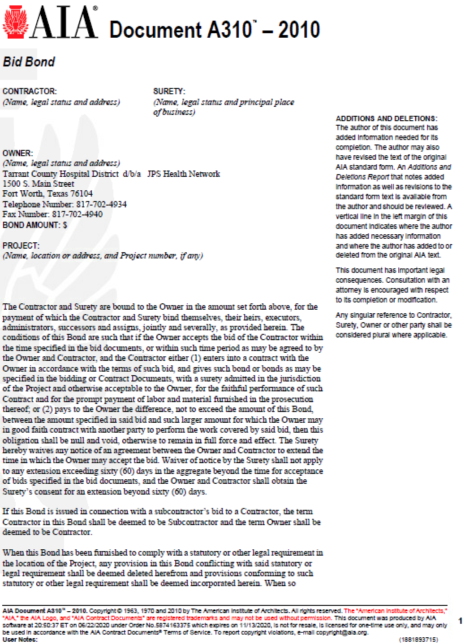
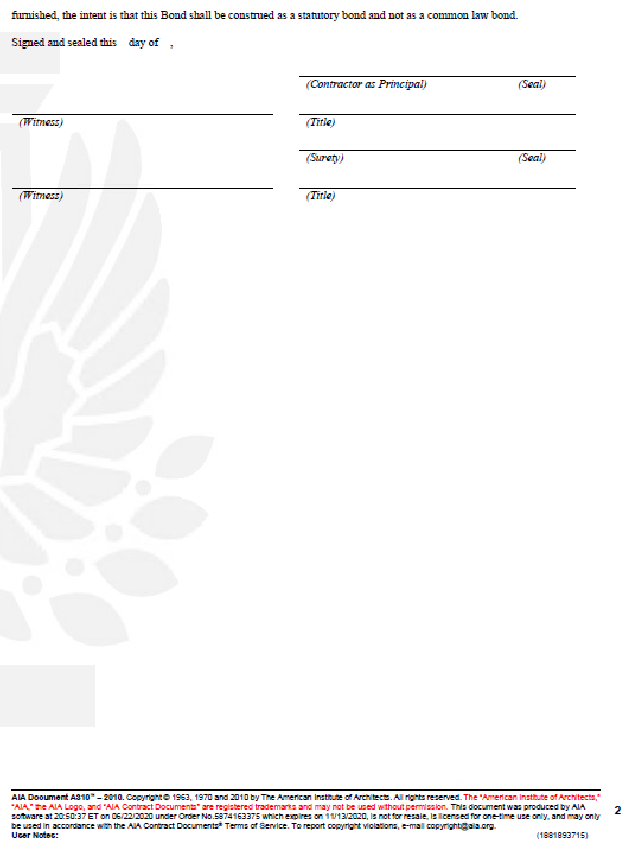

J.2 A312 – PAYMENT & PERFORMANCE BONDS

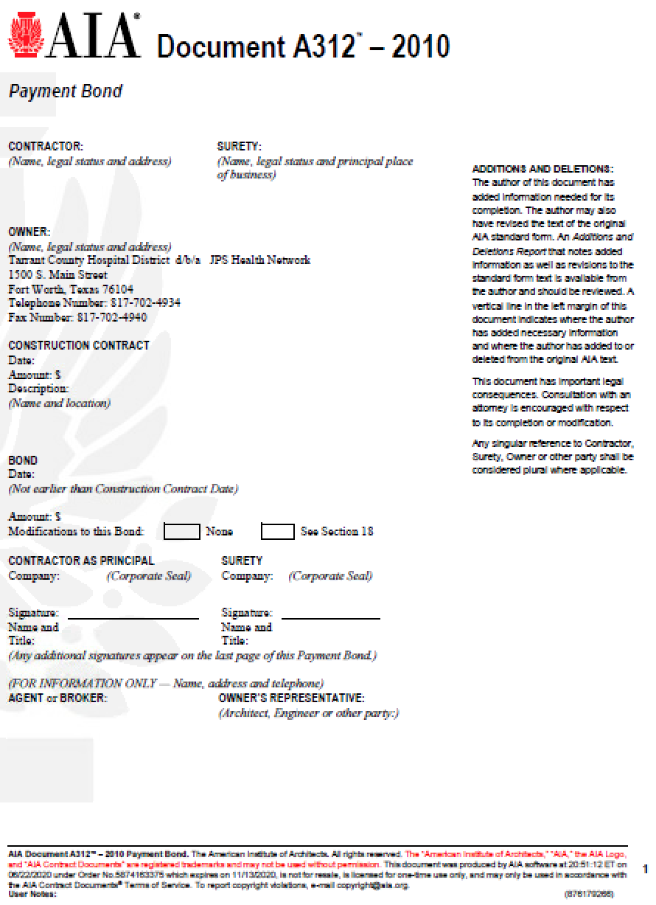
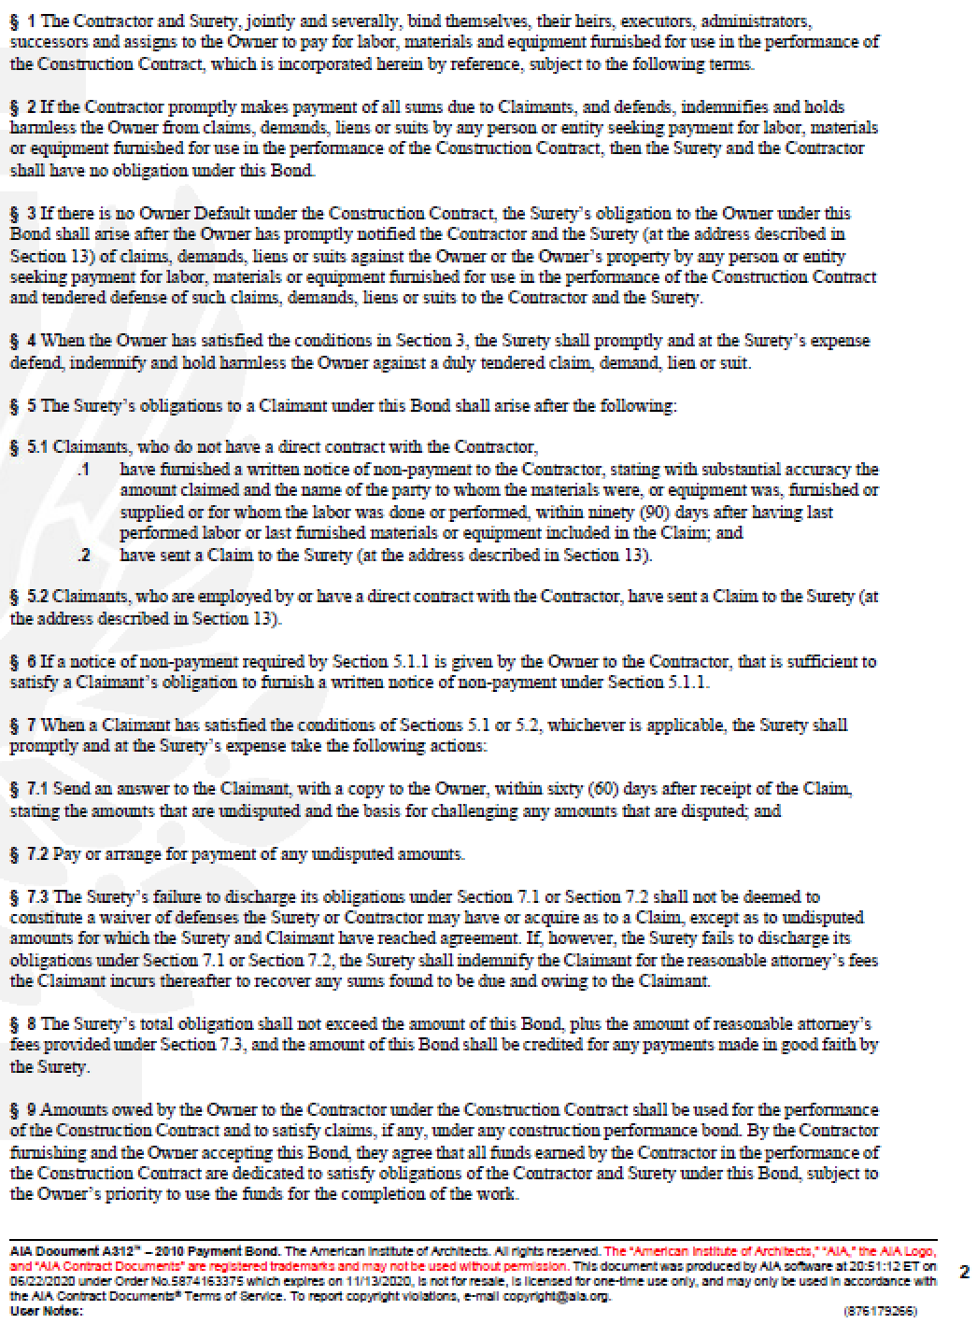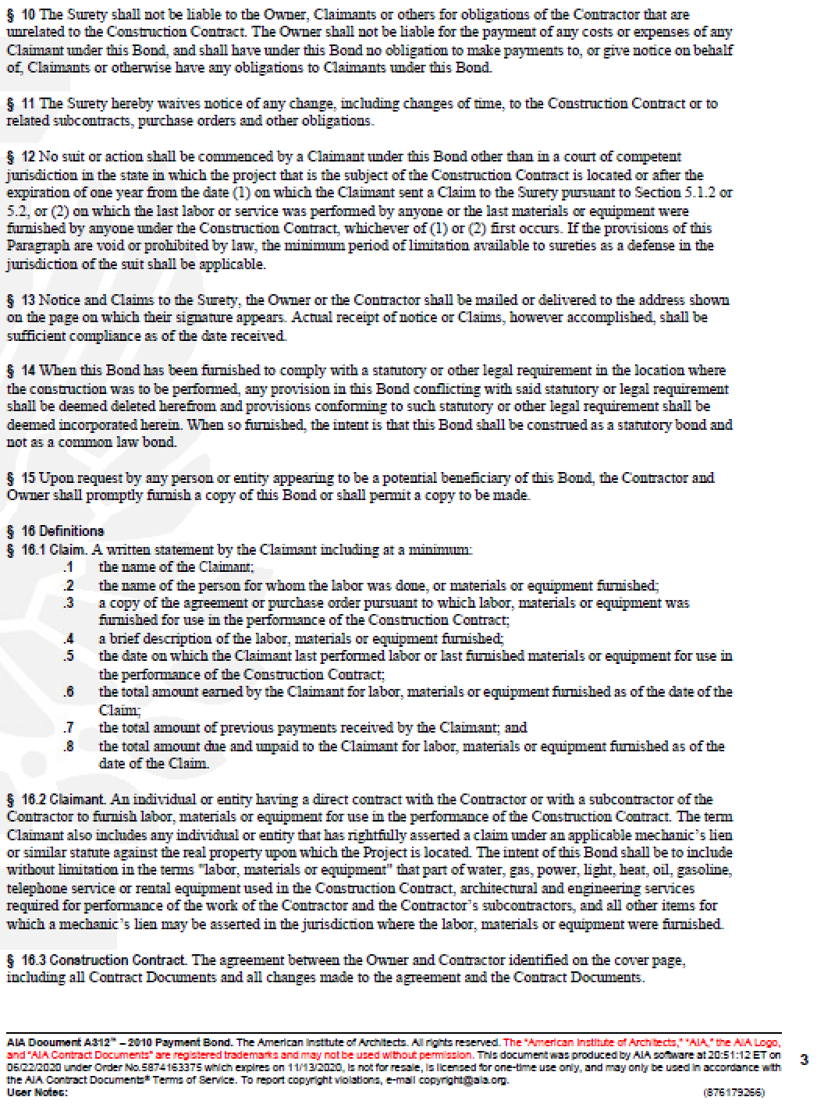
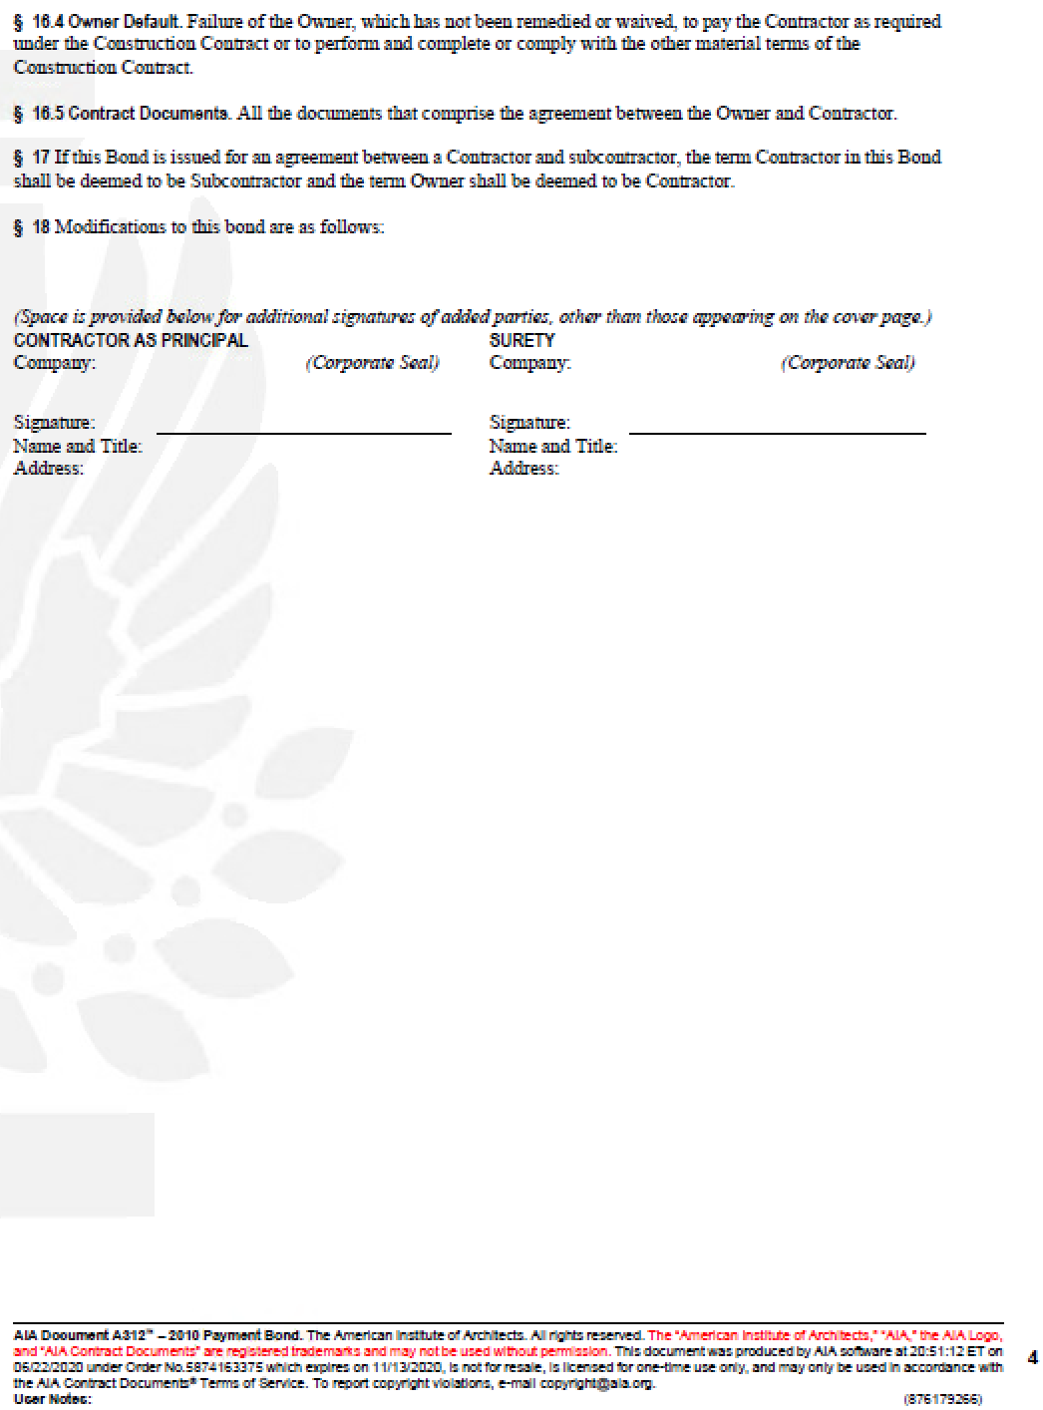
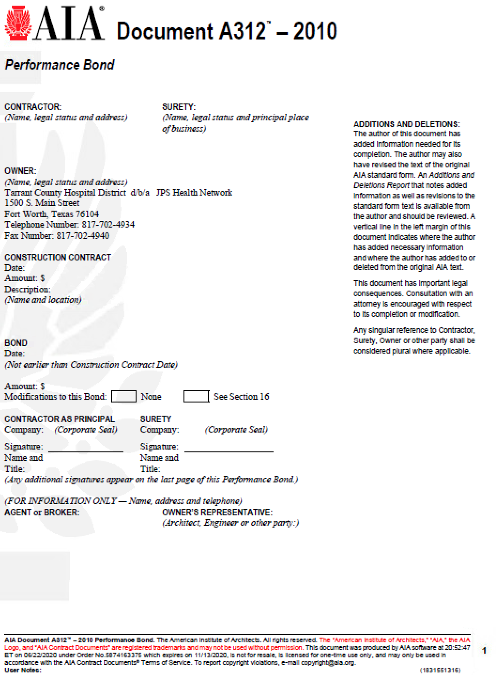
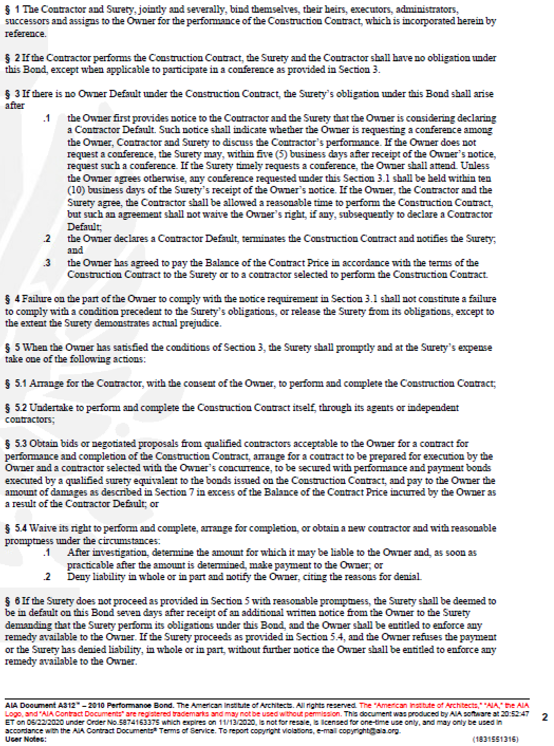
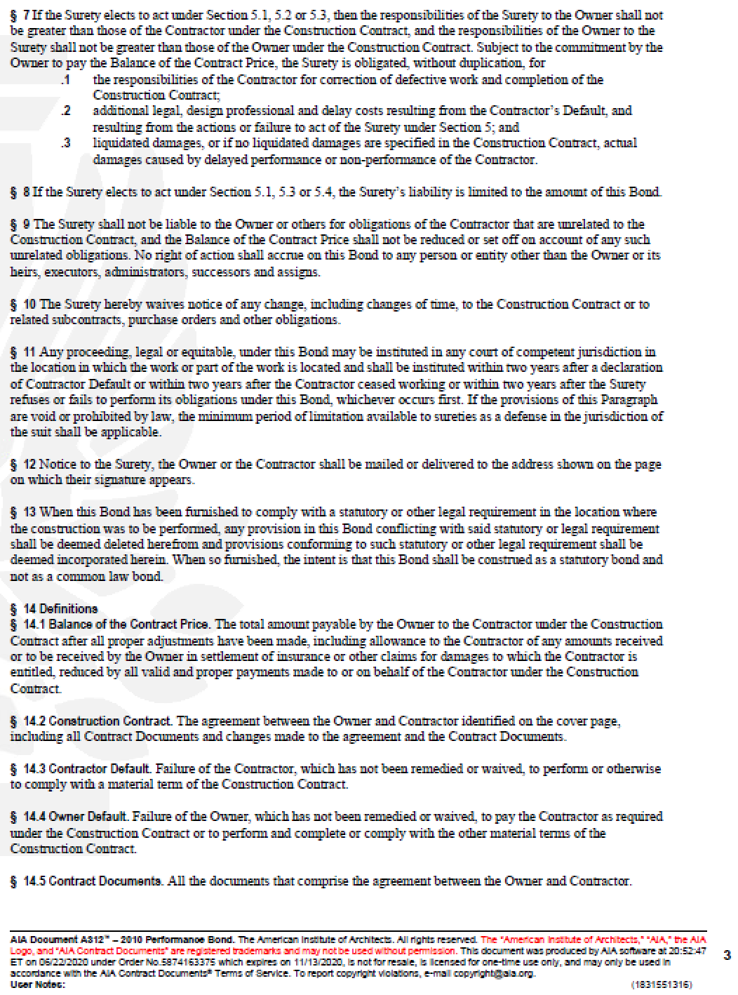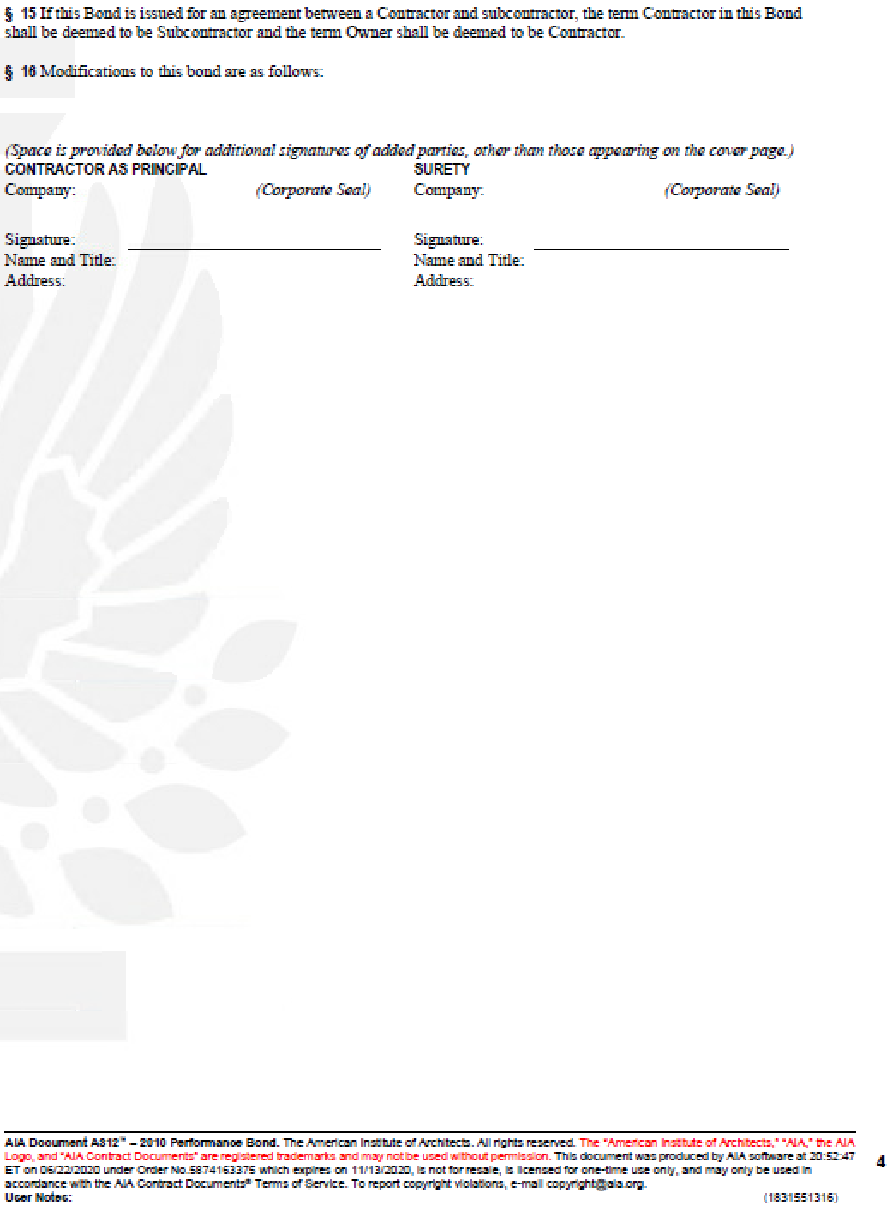

J.3 G702 – APPLICATION AND CERTIFICATION FOR PAYMENT

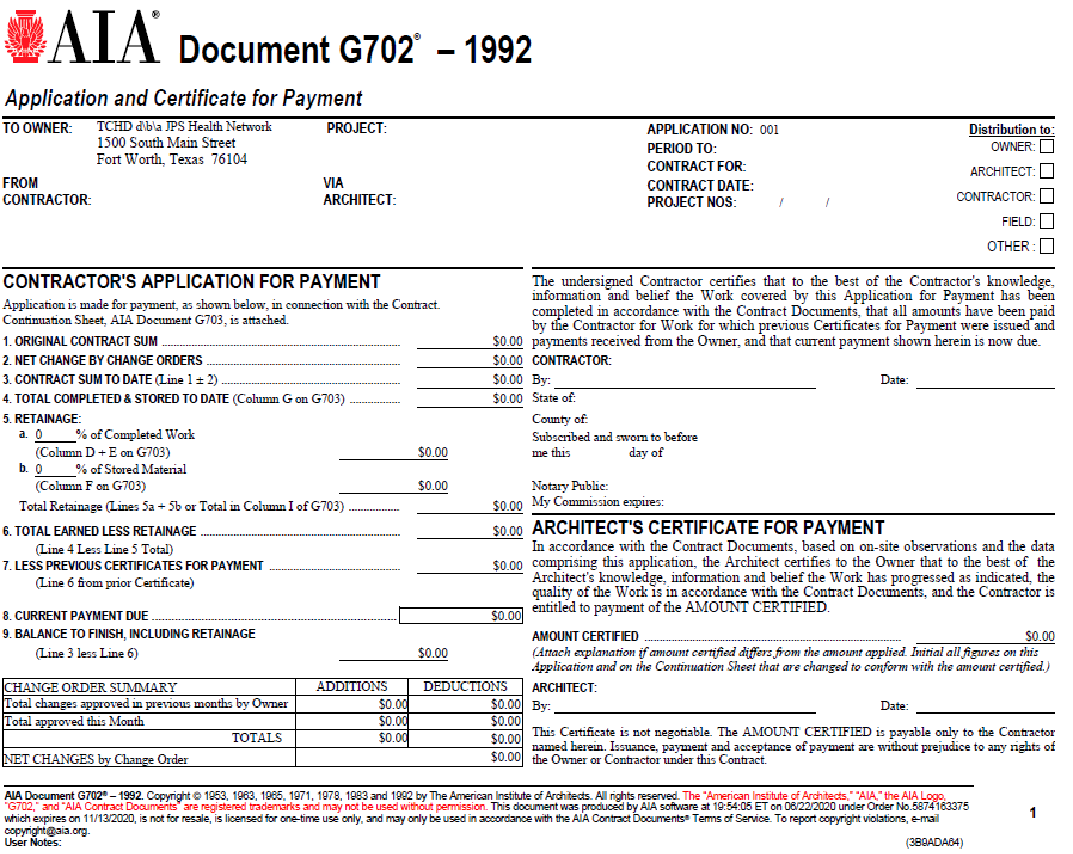

J.4 G703 – CONTINUATION SHEET

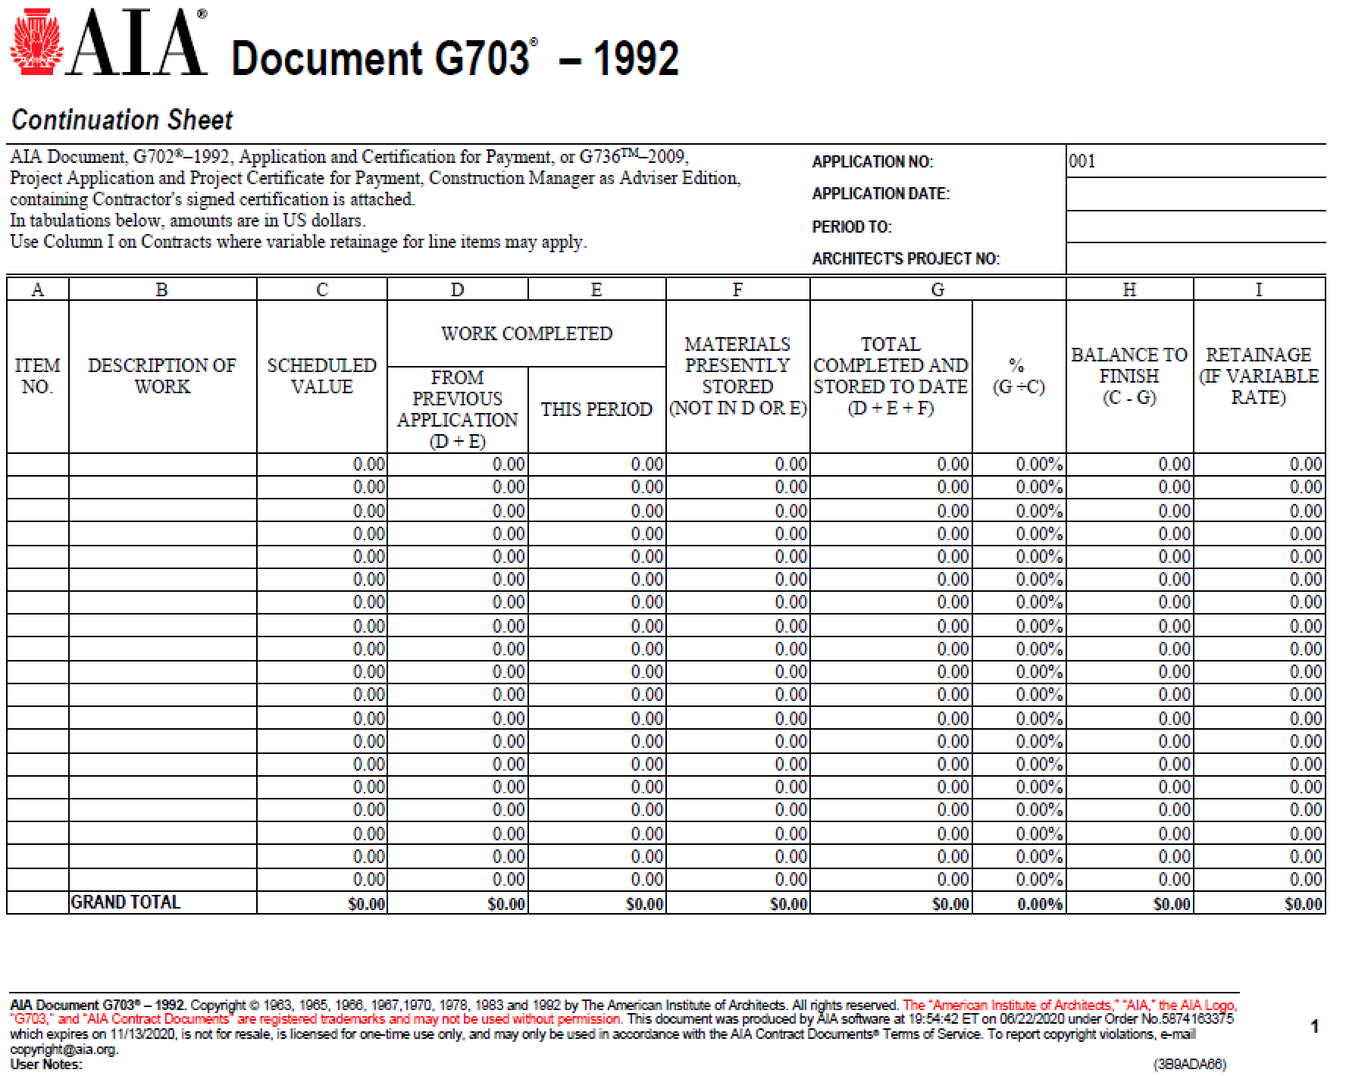

J.5 G704 – CERTIFICATE OF SUBSTANTIAL COMPLETION

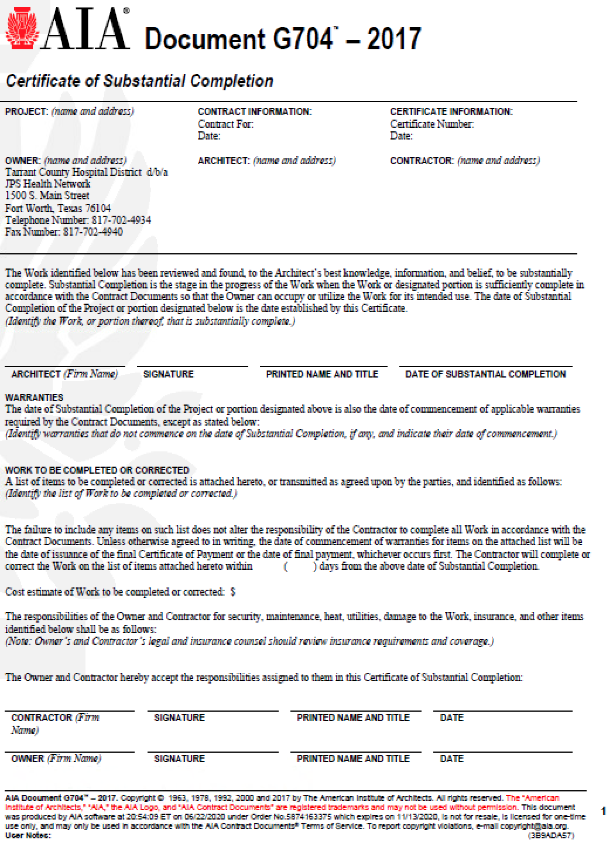

J.6 G705 – LIST OF SUBCONTRACTORS

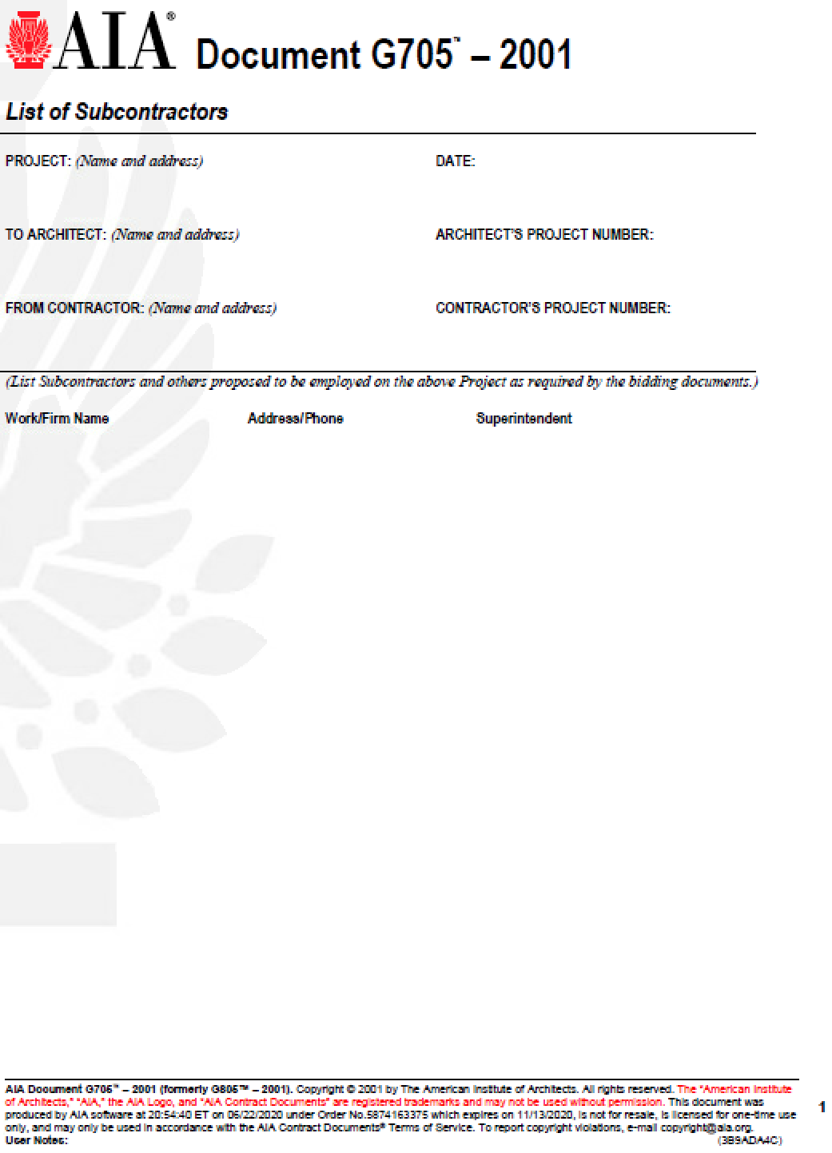

J.7 G706 – CONTRACTORS AFFIDAVIT OF PAYMENT

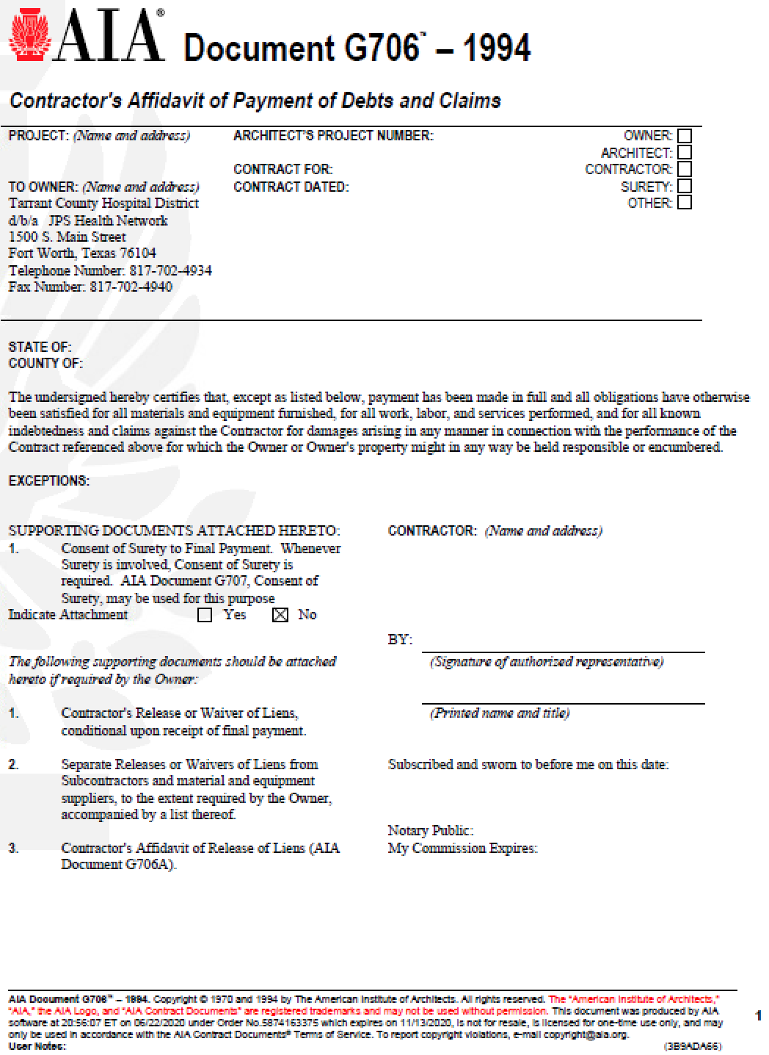

J.8 G706A – CONTRACTORS AFFIDAVIT OF RELEASE OF LIENS
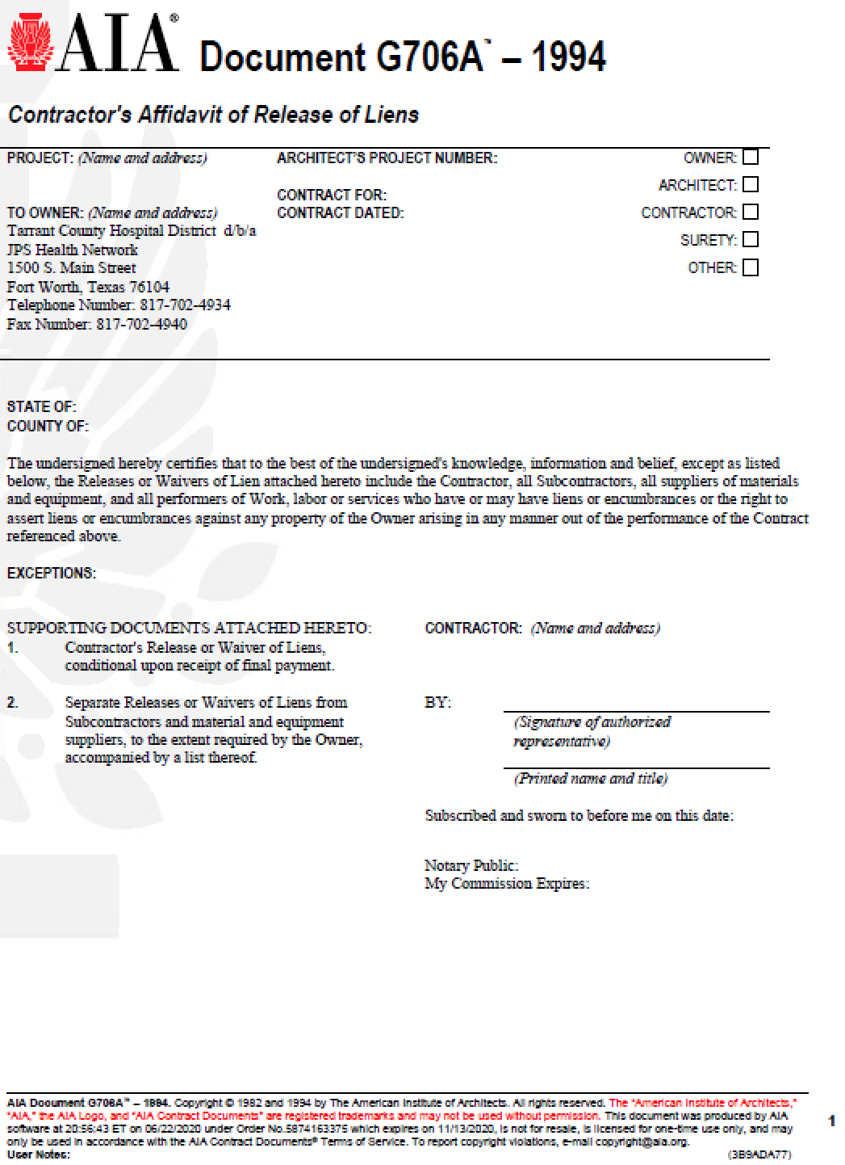

J.9 G707 – CONSENT OF SURETY TO FINAL PAYMENT

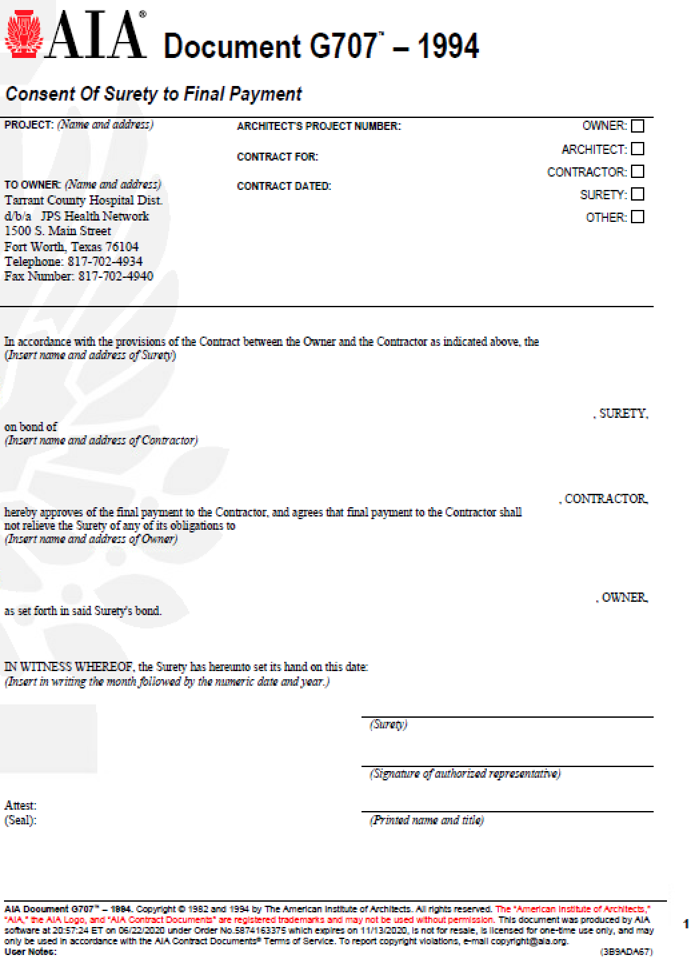

J.10 G707A – CONSENT OF SURETY TO REDUCTION IN RETAINAGE

