
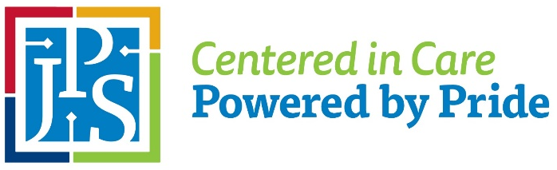
Planning-Design-Construction
1500 South Main Street
Office (817) 702-4934 | Fax (817) 702-4940
BID OPENING

RFP# 24-0402 General Contractor Services for OIC LINAC Replacement

DATE: March 11, 2026
TIME: 2:15 PM CST
PHONE NUMBER: 1-682-324-9425
ACCESS CODE: 353 776 33, then #

**In the event you are unable to access the Bid Opening per the information provided above, email Bid_submissions@jpshealth.org

